headspace YRG
(Youth Reference Group)

Information & Application Pack

Interested in joining us?
Take the next step.

Contents Page:

What is the YRG?...........................................................................................3

Getting Started……….………………………………………..…………………….4

Frequently Asked Questions……………………………………………………….6

Terms of Reference………………………………………………………………...9

Attachment A: YRG Application Form.………………………………………...15

Attachment B: Parent/Guardian Consent Form………………………….….....21

Attachment C: Photo and Video Footage Consent Form……………..………23

Attachment D: YRG Code of Conduct………………………………………....24

Attachment E: Application for YRG online membership……………………..27

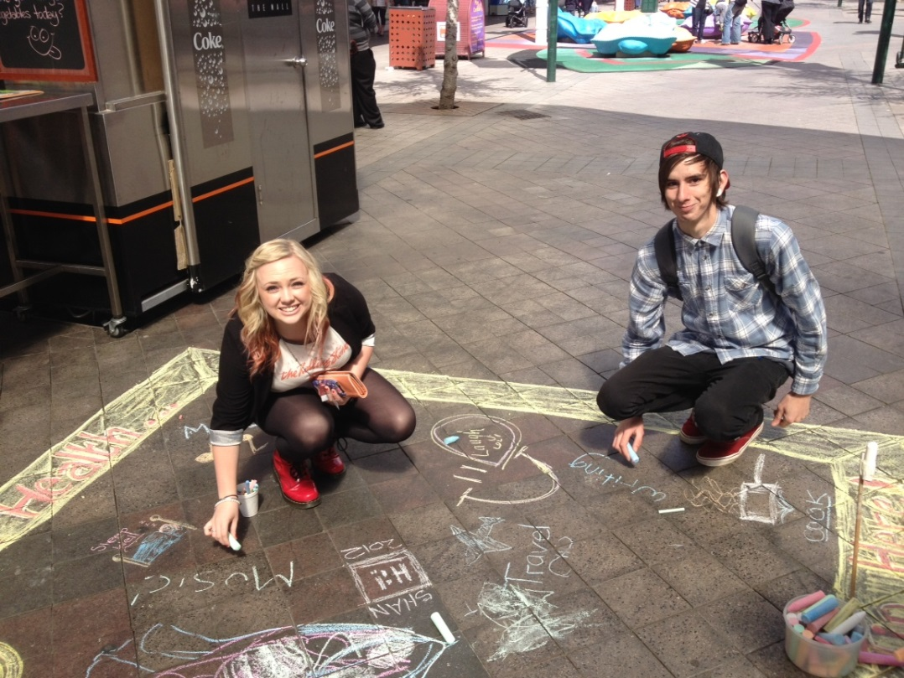

What is the YRG?
Why do we have a YRG - what’s it meant to achieve?
In a nutshell: YRG is a group of young people (aged 15-25) who meet monthly to discuss headspace in their local area, review the service and design and run activities to promote the service and provide education on early intervention and prevention for health and wellbeing

Objectives:
- To provide a space for young people between 15 and 25 to exchange ideas and resources across North-West Tasmania for mental health services for young people.
- To promote the services of headspace Devonport and headspace Burnie for young people by young people
- Involve young people in the development of our centres’ strategic direction
- To gain commitment and support for strengthening mental health service access and a holistic approach to service delivery for young people residing in North-West Tasmania.
- Provide skills development to enable young people to advocate for their needs and those of young people in their communities

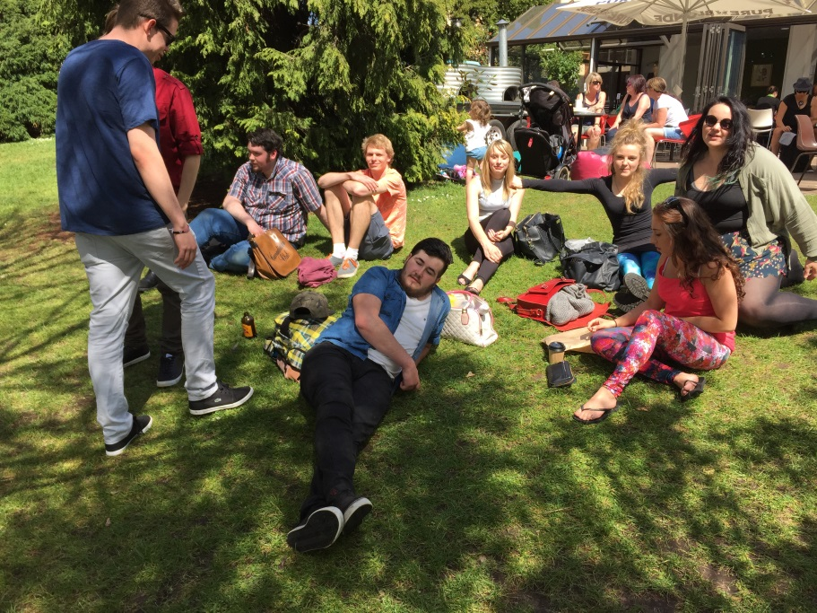
Opportunities for You
headspace provides young people with the opportunity to be heard and be active around the issues that affect them. There are a number of opportunities available to you, when you join the YRG:
- Lead a local project in Devonport or Burnie – something that raises awareness about local issues, promotes wellbeing, raises awareness about available help… heaps of different stuff
- Consult with our headspace centres and help us improve the way young people experience the service: this could include website consultation and development of content; reviewing our space (waiting area, counselling rooms); review and development of the information we give to people – fact sheets, brochures and other materials
- Do some evaluation and research with us to make sure we are delivering an effective service
- Peer support, mentoring to new and younger members
- Communicate with the public and the media and be an advocate for young people – people want to talk to you!
- We have more detail on some of these activities on page 6

When you’re involved in these things, you will:
- Develop skills – project and event planning and management; teamwork; communication… and more
- Have the opportunity to have your say and influence the way youth health services are delivered here
- Your voice is also heard by headspace National, which means your voice can influence services for young people across Australia
- Be a part of a team!
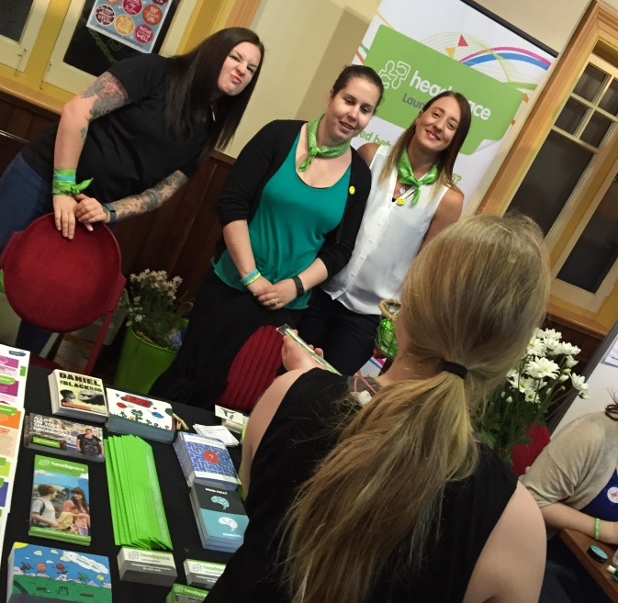

Getting Started

Then process starts as soon as you let us know that you’re interested. We ask that if you join the YRG you commit for at least a year, however you may wish to extend it longer.
Application Process:
This pack has everything you need to understand how the YRG works, as well as some forms to fill out. Read through the pack and do the forms then send it or drop it in to headspace Devonport or headspace Burnie. Hint: the application form is at the very back of this document!

headspace Devonport
Level 1, 35 Oldaker Street
Devonport TAS 7310
Ph: 6424 2144

If you are not sure of anything, contact us and ask to speak to Claire, the Community Awareness Officer (CAO) who is based at the Devonport centre on 6424 2144.
One you’ve given us the form, the CAO will get back to you by phone within the next 5 working days to arrange a time to meet.

The interview is a pretty casual and friendly meeting, between you, the headspace CAO and one or two current members of the YRG.
The interview allows you to ask some questions and get a feel for how the YRG works.
We will go through some details with you, including:
- YRG Participation Agreement
- Media Consent (To take photos and post to social media)
- Facebook Terms and Conditions
- Code of Conduct
- Wellness Plan
- Personal Development Plan
- YRG Terms of Reference

Joining?
We like to think that it’s pretty likely you’ll want to be on board, once you’ve met with us and learned about how everything works. It is possible you might not want to join and that’s ok too – maybe it wasn’t quite what you thought it was going to be, or maybe it’s just not the right time; it’s all good.
If you do want to join, that’s fantastic. The headspace CAO will meet with you again to go over the forms and see if there’s any support you need.
Next step: come along to the next meeting of the YRG, meet the other members, and enjoy yourself!

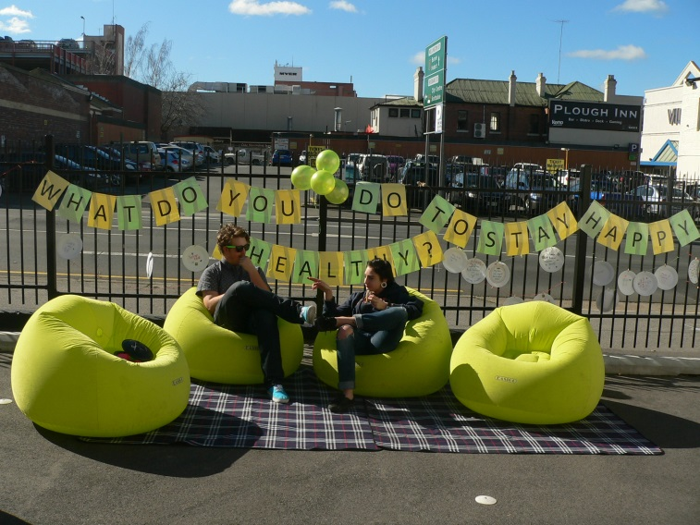
YRG FAQs
What is the YRG?
The YRG is made up of young people passionate about mental health and well-being. All members need to be between the age of 15-25 but other than that, it’s open to anyone who wants to join and will agree to be a good team member (we have rules around respect and behaviour in the Terms of Reference). Members may or may not have used the service before.

What’s the time commitment?
The appointment of members is for 12 months; depending on your age and how you’re going in the group, your membership can be renewed and you can be in the group for up to 3 years.
As a member of the YRG, you will attend meetings monthly, at a time that suits the group.
In between meetings and events, contact will be maintained through Facebook, email, online forums and teleconferences. There will be an expectation that you participate regularly in these discussions. It will also be expected that you take part in focus groups and project work related to your areas of interest.
This is a volunteer role and although you will be paid for some of the events, it is expected that you will also volunteer your time for subcommittees, projects and other events.

Can you tell me more about the activities that I can be involved in?

Community Engagement
What is it? Young people are supported to become active community advocates for youth mental health. The goal is to raise awareness of youth mental health, encourage young people to seek help early and to educate the broader community in youth mental health. Young people may be involved in community education activities, or as media spokespeople on the issue of youth mental health. You may be requested to speak at public functions or at local schools, mental health forums, conferences etc.

What are the requirements? Young people do not need to have previous experience at talking in public or to the media. Members will be supported and trained to become comfortable talking to the media and speaking at events… not everyone wants to do this, it’s not something you have to do.
What support is available for me? We won’t ask you to do anything you’re not comfortable with, and at all times you have the support of the headspace CAO and other YRG members. Not only that but when you become a member we will discuss what you feel confident with, and what you don’t, and can help you build skills and do some personal development to become a more confident speaker before you do any community engagement events.

headspace Local Projects
What is it? With support from the headspace centre staff, members of YRG will have the opportunity to lead specific projects. These projects may include, production of a headspace video, planning a fundraising event, a youth week activity, an art competition....the possibilities are endless.

Involvement in Focus Groups and Consultations
What is it? From time to time focus groups are held around specific topics to help improve headspace services. The purpose is to assure that the interests and opinions of young people are represented in all aspects of headspace activity and that service and resources are youth friendly.
When do they meet? These groups are called as needed. YRG members will be notified and asked for expressions of interest through email. It is expected that the group members would be involved in several of these a year.

Evaluation, Research, and Policy Advocacy
What is it? YRG members will have the opportunity to get involved in evaluation. Topics for evaluation will depend on the need at the time but may include – client satisfaction of a program, evaluating the effectiveness of a community event, evaluating our Facebook communications, and so on.

What costs are involved with being a member?
There’s no cost in becoming a member… in fact there shouldn’t be any costs to you throughout your time with YRG.
headspace will cover the following costs when you are involved with activities and events:
- Training
- Travel costs to attend face to face events
- Food, drinks and entrance to community events you are volunteering at

What kind of support and training will I receive?
Training will be given in a variety of areas; it really depends on what your needs are and what you want to work on. It may include:
- Leadership
- Project management
- mental health awareness
- talking to the media
- Public speaking

What happens after I’ve been in the YRG for 12 months?
Towards the end of your 12 months with the group, you will meet with the headspace CAO to talk about it – how you’re finding the group and whether you’d like to continue. If you are still in the age range and can commit to another period with the group, you can renew. Membership is for up to 3 years.

Why can members only be involved for 3 years?

If after 3 years you still want to be involved it hopefully means you’ve had a blast and really got a lot out of it, which is what we want. We also want to give these same opportunities for others but to keep the group to a reasonable size, we have to say goodbye to members as well as saying hello and welcoming new members. If you want stay involved with the community there will be many options – the CAO will help you find them.

What are the rules – respect and looking after each other, and other stuff?

Glad you asked! All of our most important rules that members need to follow are in the Terms of Reference on the next page.

Youth Reference Group (YRG)

Terms of Reference (ToR)

- Review of the Terms of Reference:

The YRG terms of reference will be reviewed every 12 months

- Purpose of YRG

The purpose of the headspace Advisory and Reference Team (YRG) is to:
- Provide a space for the exchange of ideas and resources, and assist headspace Devonport and Burnie centres deliver services that are relevant, effective, youth-informed and client-focussed. The perspective and input of YRG is also expected to benefit the Lead Agency, Cornerstone Youth Services Inc, and headspace National.
- Empower and develop young people, and through their participation help them develop valued knowledge and skills.

- Objectives of YRG:
- To provide a space for young people between 15 and 25 to exchange ideas and resources across North-West Tasmania for mental health services for young people.
- To promote the services of headspace Devonport and Burnie for young people by young people
- Involve young people in the development of our centres’ strategic direction
- To gain commitment and support for strengthening mental health service access and a holistic approach to service delivery for young people residing in North-West Tasmania.
- Provide skills development to enable young people to advocate for their needs and those of young people in their communities

- Accountability

YRG is directly accountable to, and supported by, the headspace Devonport and Burnie Centre Manager. The day to day operation of the YRG and support to members is provided by the headspace Community Awareness Officer.

- Confidentiality
YRG members are required to sign a Confidentiality declaration (Attachment B).
At times, there will be items of a sensitive nature that are discussed; the headspace Community Awareness Officer will identify these items during the meeting and remind members that these discussions need to be kept confidential – not for discussion outside the meeting.

- Code of Conduct
YRG members are required to read and sign the YRG Code of Conduct upon joining the group. Where a member extends membership beyond 12 months, the member will be asked to read and sign the Code of Conduct at the commencement of their membership extension.

- YRG member position description

  - YRG members will consist of up to 13 young people between the ages of 15-25 at the time of application.
  - Members do not need to be current or former clients of the service but do need to be committed to helping headspace Devonport and Burnie improve the lives of young people experiencing health issues.
  - It is hoped that the YRG will be represented by a broad range of the young people of the North-West of Tasmania. To promote diversity in the group headspace may, at its discretion, seek out and invite membership from young people in the community who identify as a member of a diverse group, including and not limited to:
- Lesbian, gay, bisexual, transgender, intersex, and questioning
- Aboriginal and Torres Strait Islanders
- Culturally and linguistically diverse
- People from a low socio-economic background, people with an experience of homelessness

  - We seek members who have:
An interest in mental health and/or drug and alcohol issues and the health of young people
The ability to see the big picture
Motivation, willingness and commitment to participate on a long-term basis
Good communication skills
The ability to balance the demands of YRG with their own health and other responsibilities such as school or work
Access to the internet and phone

- Responsibilities of YRG members:
    - Participate in monthly meetings
    - Be prepared to undertake some training about headspace, mental health, mental illness, talking to the media and associated topics
    - Complete a wellness plan and actively look after all aspects of your health
    - Complete a personal development plan and contribute to the development or the YRG work plan (described below)
    - Be open and willing to participate in teleconferences, email and Facebook discussions
    - Support local headspace activities
    - Some young people may like to become community advocates for youth mental health which will: raise awareness of youth mental health, encourage young people to seek help early and to educate the broader community about mental health
    - Young people may be involved in community education activities, as media spokespeople, as speakers at public functions or at local schools, forums or conferences

Work Plan and Activities of the YRG
Members may become involved in a range of activities and projects in their time with YRG. In order to ensure that activities and projects are safe, within the scope of members, and appropriately represent the interests of headspace Devonport and Burnie as well as the interests of headspace National, all activities must be approved by the headspace Community Awareness Officer, before commencement.
Activities and projects will be decided by negotiation between members of the group and headspace Devonport and Burnie as represented by the Community Awareness Officer.
Individual Activities – Personal Development Plan (PDP)
Within the first month of joining, members will meet with the headspace Community Awareness Officer to discuss a personal plan. This allows the service to understand the needs of the young person joining, to ensure that over the course of their time with the YRG they are able to grow and develop in areas that challenge and interest them. The Community Awareness Officer and YRG member will fill out a Personal Development Plan and then meet individually to review the plan no less than once every 6 months or earlier at the request of the member.
Activities and supports to be provided under the Personal Development Plan will be in line with the purpose and objectives of the YRG Terms of Reference, and activities that are outside this scope will not be supported. In general, the types of activities that will be supported in a PDP will include mentoring support from the Community Awareness Officer to develop confidence and skill in public speaking, project management, and other skills to build confidence in organising, advocacy, and communication.
The PDP is also intended to identify and respond to support needs that the member may have, in order to participate fully in the YRG. A member under the age of 18, and any member currently receiving support for personal and mental health concerns, will require extra support and this will be identified in the plan. See also section 10 for information on the types of support available.
Wellness Plan
headspace acknowledges that young people can and should take responsibility for their wellbeing however we also have a duty of care for the wellbeing of young people involved in the YRG. We ask that when becoming a member of YRG, each new member talk with the CAO and complete a wellness plan. This will assist the CAO to help you feel comfortable and supported.
Group Activities and Projects – the YRG Work Plan
At the beginning of the calendar year the will meet with the headspace Centre Manager to discuss the priorities of the centres for the year ahead, based on information about:
- Demographics about the young people who are accessing the service, and the demographics of those who aren’t coming into the service – age range, gender, where people live etc
- Communication events and strategies being rolled out by headspace National – what events or activities we can run to in conjunction with these strategies
From this discussion a work plan will be developed between the YRG, Community Awareness Officer and Centre Manager to decide on a number of projects for the YRG to undertake, over that year. There will still be flexibility for the team to take on new activities over the year; the work plan will outline the major priorities and requirements from the group, for the period.
New members can join at any time of the year but will be required to commit to the priorities and projects outlined in the YRG Work Plan for that period.
Other Activities
There are several set activities that YRG is required to have involvement with:
- headspace Consortium
The headspace Consortium is a group of local services that meets every two months to support headspace. Members are usually leaders of local health and other agencies and meet to discuss the activities and challenges facing headspace and provide solutions – suggestions and ideas, linking us with other people and agencies who can help, and sometimes offering headspace resources such as staff coming to work on site.
For the Consortium to be youth-focussed it needs the perspective of young people represented at Consortium meetings; we require the YRG to select and support 1-2 members to attend the Consortium meetings on behalf of the YRG and on behalf of young people. The member or members who attend this meeting will be supported by the headspace Centre Manager who also attends Consortium meetings.

- Cornerstone Youth Services Inc Board of Management
Cornerstone Youth Services Inc (also known as Cornerstone) is the organisation that runs the headspace program. The Board makes decisions on all major aspects of the running of headspace and other programs run by Cornerstone. The Board requests a representative of the YRG to attend a Board meeting once per quarter, to report on the activities of the team including progress on the YRG Work Plan. YRG may have 1-2 members represent to the meeting and will be supported at the meeting by the Cornerstone CEO. Members will be supported by the headspace Community Awareness Officer to understand what is expected of them and assisted in preparing the small report that is given by the YRG representative/s at the Board meeting.

- Operating Procedures
Chairperson and Secretary
At the time of writing it is determined that the position of Chairperson will be held by the headspace Community Awareness Officer; this will be reviewed and it is expected that as the operation of YRG continues over time, that the position of Chairperson will be performed by YRG members in a manner that members can decide upon.
9.1 Schedule and Location of Meetings
Meetings will be held on a monthly basis at headspace Devonport, with video conference facilities to be used so that members can attend either centre to attend.
From time to time members and the headspace CAO may agree to have additional meetings, or for some members to have additional meetings where they are working on specific projects (e.g. preparing for an upcoming community event).
Members will also be required to meet individually with the headspace CAO to develop and review their Personal Development Plan, at least 3 times a year and more if requested by the member or if suggested by the CAO.
9.2 Quorum
A quorum is 50% of members plus one. If a quorum is not reached a meeting may still go ahead on consensus and decisions can be made by attending members.
In most cases YRG will decide as a group if a decision is to be made by vote, however as Chair, the headspace CAO can decide on what matters will be decided by vote. There may be circumstances where a topic has wide implications for the headspace centres and/or Cornerstone Youth Services and as such the CAO will ensure that the YRG operates within the limitations of its scope.
9.3 Agenda and Minutes
The agenda will be set by the headspace Community Awareness Officer, and headspace Centre Manager.
The agenda will be posted to the YRG private Facebook page at least 48 hours prior to the meeting and emailed to all members.
Minutes will be posted to the YRG Facebook page and emailed to all members no later than 7 days after the meeting.
Reports or other relevant documentation as required will also be distributed with the minutes.

Minutes:
Minutes will be taken at every meeting. The details of these will be of a standard that they can be understood by a member who has not attended the meeting.
Minutes will include:
- Date, meeting start and finish time, attendees and apologies
- A brief statement on the topics raised
- Action points – what progress is expected, from which members, before the next meeting

- Welfare of the Members of the YRG
headspace Devonport and headspace Burnie, and its Lead Agency Cornerstone Youth Services Inc, has a duty of care to YRG members. Whilst all member will receive the organisation’s care and support, members under the age of 18 and those currently accessing support for personal and mental health concerns, require extra support to participate to their full potential within the group.
Each member joining the group will discuss their needs with the headspace CAO as part of preparing their Wellness Plan. The organisation will support the member and consider various ways of doing this including but not limited to – limiting the amount of time a person participates in meetings, providing additional break times, restricting or tailoring tasks and responsibilities, and so on. Discussions about individual needs will be done individually.
If a member is experiencing considerable distress, the CAO may ask for the direction of a member of clinical staff. This may or may not mean asking that staff member to meet with the YRG member directly; wherever possible we will respect the wishes of the YRG member including the need for privacy, however duty of care for the safety of the member is the priority and this may mean communicating with a member of clinical staff if necessary.

Attachment A:
YRG application form
Personal Details
Name
Phone
Email
Address

Date of Birth
Sex

What languages do you speak at home?

Where were you born?

Are you Aboriginal or Torres Strait Islander?

Are you from a rural or remote area?

Do you have a family member with a mental illness?

Do you identify as having/had mental health issues?
Is this something that you would be happy (and feel comfortable) talking about?

About You

Please tell us a bit about yourself
(For example: I am 15 years old, and attend alternative education centre 3 days a week, I like skate-boarding etc)

Why do you want to be involved in headspace?
Please describe why you are interested in becoming a hART member?

What type of headspace activities would you like to be involved in?

What skills and ideas could you bring to hART?

Are you involved in any other organisations? If yes, which ones and what is your involvement?

SUPPORT PEOPLE

We would like the contact details of two support people.
Who should you chose?
Consider someone that you believe will be able to:
- Provide us with information to support your application
- Be prepared to support your involvement if you are accepted onto the YRG
- Be able to provide you with support (if needed), if you are not accepted
- Be an alternative contact point if we can’t get in touch with you
Your support people may be a family member, a work colleague, youth worker, counsellor, or anyone else that provides you with support and knows you well.

Remember: one support person needs to be involved with your headspace centre

Support person 1
Name
Relationship to you: eg family member, boss, counsellor etc.
Phone
Mobile
Email

Support person 2
Name
Relationship to you: eg family member, boss, counsellor etc
Phone
Mobile
Email

In providing these details to headspace, I understand that the above people may be contacted in the following situations:
• To provide additional information to my application
• If headspace is unable to contact me by email or phone and is concerned about my wellbeing
• If I am not accepted to YRG and headspace has reason to believe that I may need support around this outcome

Signed: _________________________________

Name:______________________________________

Date: _______________________________________

I (name) ________________________________________________

of (address) __________________
__________________
__________________
__________________

I acknowledge that I have received and understood the following (please tick):

- Letter of appointment (letter received with this document)

- YRG information and application pack

- YRG Terms of Reference

- YRG Code of Conduct

- Consent Form of Persons Photographed/Videoed

I understand that:
- My appointment as a headspace Youth Advisory Group member for 12 months and that after this period I can renew for a further 12 months up to a maximum of 3 years membership

- I may have to undergo a police check if I will be involved in headspace activities with young people under 18 years ages including working with schools, speaking at public functions, forums or conferences. More information will be provided in relation to this at the first face to face meeting.

- My membership may be terminated in the event of breaching the YRG Code of Conduct

I confirm that:

- I wish to become a member of the headspace Youth Advisory Group

- I am willing and open to participate in teleconferences, email and web discussions

- I will work cooperatively, respectfully and in a considerate manner with headspace staff and other YRG members, and in accordance with the YRG Code of Conduct

Signature: ____________________________________

Date: ____________________________________

If further information is required please do not hesitate to call Claire, Community Awareness Officer on 6424 2144 or email cstucas@csys.com.au

Emergency Contact Information:

Name: ________________________________________________________

Relationship to you: ______________________________________________

Residential address: _____________________________________________

City/Suburb:__________________________ State: _______Postcode: _____

Home Phone:_____________________ Mobile: _______________________

Please note: members under the age of 18 years at time of acceptance of headspace YRG member need to also submit completed parental/legal guardian consent form.
Attachment B:
Parental/ Legal Guardian Consent form

If a headspace YRG member is under the age of 18 years at the time of acceptance of volunteer position, parental/guardian consent is required for the member to participate.

As parental/legal guardian, I have read and agree to the details laid out in:
- YRG information and application pack

- YRG Terms of Reference

- YRG Code of Conduct

- Consent Form of Persons Photographed/Videoed

Young Person Name: ____________________________________________

Parental/Legal Guardian Name: ____________________________________

Address: ______________________________________________________

State: ____________ Postcode: __________

Telephone: _________________________ Mobile: ____________________

Parental/
Legal Guardian signature: _________________________________________

Date: ______________________
If further information is required please do not hesitate to call Claire, Community Awareness Officer on 6424 2144 or email cstucas@csys.com.au

Attachment C
Photo and Video Footage Consent Form
Consent Form of Persons Photographed/Videoed:
headspace, the Youth Mental Health Foundation, is committed to raising awareness about youth mental health. As such, headspace is keen to highlight young people’s opinions, stories, photographs and videos. The following form relates to headspace marketing and media activities.

All persons featured in photograph/video must be aware of how the images and names will be used and must give their consent. Permission must be obtained from a parent, spouse or legal guardian for persons who are under 18 years of age.
Your image may be used in promotional materials about headspace, the services headspace offers, mental health issues (such as depression and anxiety) or important youth issues (such as exams stress, relationship break-ups, cyber bullying and same-sex attraction).

headspace may use the images taken of you in the photo shoot in a range of materials (including but not limited to: flyers, posters, banners, reports, etc) and across multiple platform (such as social media, website, in centres).

While headspace has control over the development and production of the promotional materials, it is important to understand that once promotional materials are made public, headspace will no longer be able to control where or how those promotional materials are used, how long they are displayed in public or are accessible on the web. Any web-based images and other material may remain accessible to the world at large for an indefinite period.

In signing this Consent, you release headspace from any liability (to the maximum extent permitted by law) relating to your participation in being photographed and the use of your image in headspace’s promotional materials.
If you wish to withdraw your consent, you may do so by sending written notice to headspace at 31-33 Steele Street Devonport 7310, or by email to headspace@csys.com.au

Your privacy
Your image is personal information under the Privacy Act 1988 (Cth) and is covered by headspace’s privacy policy.
headspace’s privacy policy provides further information about:
  - How you may access and correct personal information that headspace holds about you
- How you may complain about a breach of privacy and how headspace deals with privacy complaints

If you would like to read headspace’s privacy policy, please go to headspace.org.au/privacy-policy.
I have read the background information and give headspace the right to use my photograph/video, words or story and name in headspace publications, on its website or in media promotions as headspace sees fit.
I consent to photographic images being taken of me as part of this event, and I acknowledge that those photographic images:
- Belong to headspace

- Are intended to be used by headspace in its promotional materials

- May be digitally edited by headspace

- May be published with an accompanying caption

I understand that my participation is voluntary and even if I change my mind, it will not impact on my right to be involved with headspace. I understand that while headspace will try to protect my interests, once I participate, headspace may not have control over what gets published, or how the media or public use the photographs/video. I am over 18 years of age. I have read this release and I am familiar with its contents.

Name:__________________________________ Date of Birth:

Address: ______________________________________________________________________________

Email: ______________________________________________________________________________

Signed___________________ ____________________ Date_____________________

Witnessed by (Print Name): ________________________Signed___________________
Consent for persons to be photographed/videoed under 18 years of age
I am the parent or the guardians of the minor named above and have the legal authority to execute the above release.

Parent or Guardian Name_________________________________________________

Signed________________________________________________________________

Address_______________________________________________________________

Phone No:_________________ Mobile Phone:_________________ Date___________

If further information is required please do not hesitate to call Claire, Community Awareness Officer on 6424 2144 or email cstucas@csys.com.au

Attachment D
headspace Youth Reference Group (YRG)
Code of Conduct

Being a YRG member is a great opportunity to promote the positive image of young people and mental health and substance use issues, including early intervention and help seeking. Your behavior as a member of the YRG should enhance the reputation of headspace, and what it stands for as well as being considerate of other members’ needs.
Values
YRG members are asked to behave in a way that shows support and respect – the same values that we show in our work at headspace.
Participation
headspace recognises that individuals have different commitments outside of YRG leading to different individual time and availability, as long as this is discussed with the headspace Community Awareness Officer, arrangements can be made to take time out from activities.
If a member does not participate in meetings, email and other events, a review of that person’s commitment may take place if no apologies have been made.
If a member wishes to select out or resign or take a break from the group; notification in writing (email is ok) to the CAO is required.

Support:

Being supportive can mean many things but overall it is about wanting your team members to feel comfortable to enjoy themselves in the group and get the most out of themselves; it’s listening, encouraging, making room for other people’s ideas and opinions, and being dependable – getting to meetings and doing the jobs you agree to do.

Respect:
Respect in YRG means treating others with the sensitivity, courtesy and understanding we would wish for ourselves, and recognising that everyone has something to offer. It means thinking “would I be happy if this was happening to me” and rests on a foundation of fundamental decency in our dealings with colleagues and clients alike. Respect is shown in many ways, from using the preferred name and pronoun a person has, to active listening, and sharing opinions and agreeing or disagreeing without insults or put-downs. This is in all settings where communication occurs: in person and at meetings, by email and communication on the YRG webpage.

Problem Solving & Dispute Resolution
Any complaint, unresolved problem or serious dispute that involves members is to be brought to the Community Awareness Officer (CAO) for resolution. If appropriate, and with the agreement of all parties, the matter may involve a mediation process. A range of mediation options will be made available.

headspace Devonport and headspace Burnie reserves the right to exclude any young person if headspace believes the young person has acted inappropriately. If such steps are taken, the member’s participation with headspace will be reassessed and may mean a predetermined timeframe of exclusion from the group or immediate expulsion.

Care and Support for YRG Members
headspace promotes early intervention and help-seeking for mental health and drug and alcohol issues. It is therefore expected, that as a representative of headspace, you acknowledge this and you yourself seek appropriate supports when required. Therefore, if at any time you feel you need to take a break, seek help or support then headspace will respect this.

I have read the information contained in this document and agree to abide by the YRG Code of Conduct.

Print name: _________________________________

Signature: _________________________________

Date: _________________________________

Attachment E

Application for YRG online membership

I (Print Name)_______________________________________________ agree to the following code of conduct and user agreement for online membership with YRG/Cornerstone Youth Services (cornerstoneyouthservices.com.au).
- I acknowledge that the forums are not monitored or moderated by Cornerstone Youth Services (CYS).
- I am responsible for what I post in the forums and I will not post or participate in bullying, threats, hate speech or other inappropriate discussion in the CYS/YRG forums.
- My conduct in the YRG will be consistent with the YRG Code of Conduct.
- If I become aware of any bullying, threats, hate speech or inappropriate use of the forums I will notify Cornerstone Youth Services Immediately.
- I will not share my login details with any other person, and will ensure I have logged out of my account before allowing others to use my device – especially on shared computers/devices.
- All information provided on the YRG membership platform is private and confidential, and I agree not to share it outside of the group.
- In the event of my account being hacked or undermined I will notify Cornerstone Youth Services as soon as possible.
- Failure to comply with this agreement can result in my account being suspended or permanently deleted.
- I understand that it is impossible to guarantee against hacking and the illegal exploitation of data. I agree that while Cornerstone Youth Services take reasonable steps to ensure the safety of my data, in the event of illegal hacking or data breaches I will not hold Cornerstone Youth Services responsible for any of my data stored on the website being hacked, exploited or otherwise accessed.

Name: _____________________________________________________
Email: _____________________________________________________
Signature: __________________________________________________
Date: ____/_____/___________

