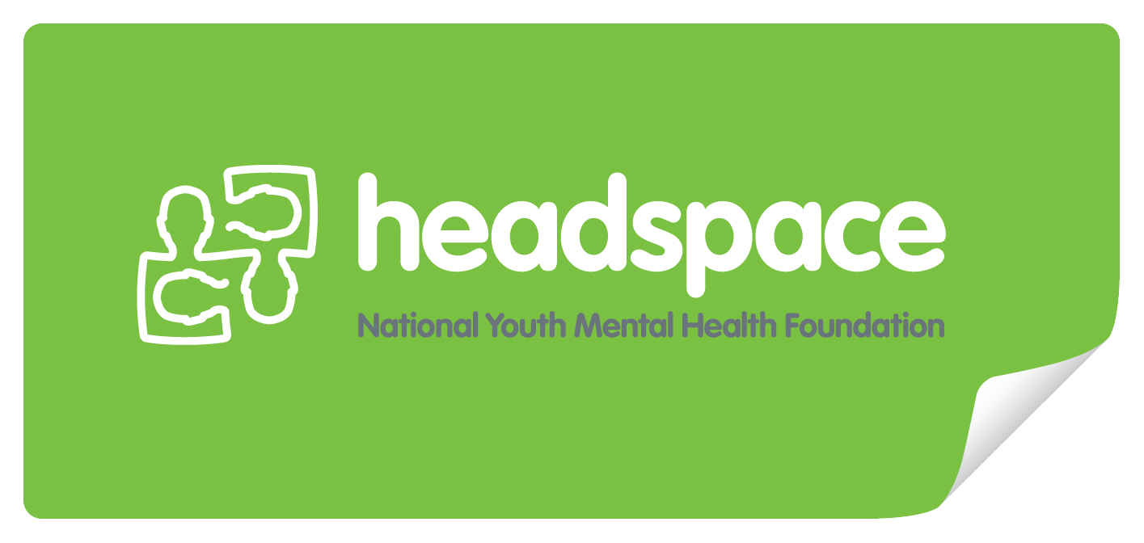

Career planning checklist
08
Fall
- Do you need additional job skills, experience or information?
- What areas of yourself will you need to develop?
- Do you need to develop a wider network or links with specific people?
- Is there a course you need to do (perhaps to gain specific qualifications or skills)?
- Do you need to find ways to demonstrate your skills and knowledge so you can provide evidence of what you can do?
- What actions do you need to take to realise your career goals?
- Do you need to find out more about what would be required to achieve your career goals?
- Do you need to find out more about what is available? If so, how will you do this?
- What kind of work experience would be helpful to you?
- What new job skills or knowledge will you need?
- Do you need to demonstrate you have job skills in particular areas?
- Are there contacts you can make, or relationships you can develop, that might help you?
- Are there any changes you could make to the way you deal with people or work situations that might increase your likelihood of achieving your goals? How will you start to do this?
- Who can you discuss your goals with? When will you do this?
- Are you clear about the type of work you would like to do? How can you clarify this further?
- Do you have a supportive network? Do you believe you are recognised as able to contribute information to this network? If not, what could you do about this?
- Do you have a mentor with whom you can discuss both the technical content and the intangibles of your job? If not, have you thought about finding a mentor? Is there someone in your workplace or elsewhere you could approach?
- Do you need to make some radical changes to your present direction? What are the first steps to achieving this change in direction and how will you take these steps?
- Do you think you will need to undertake further study? What steps could you take to do this?
- Do you feel in charge of your own career direction? If not, how can you gain more confidence and take charge?

