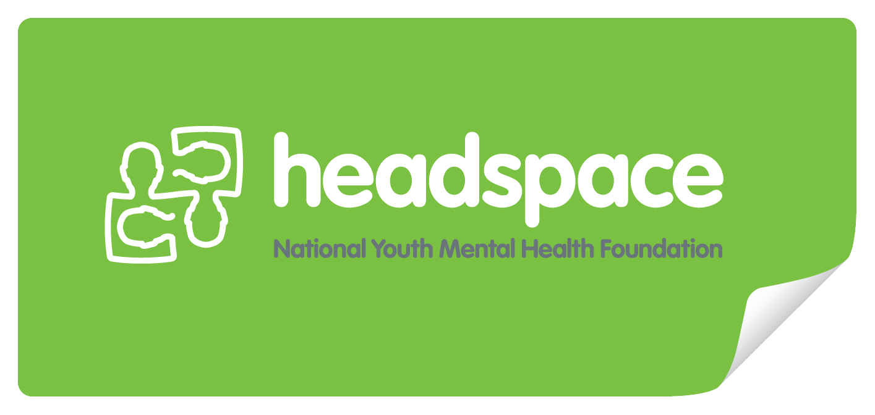

Career Plan Template
08
Fall

Personal Data

Name:
Career Plan Update:

Career Field and Specific Jobs

Write a general description of the career field (Healthcare, for example) you plan to pursue and why this career field appeals to you. Explain how your interests, work values, skills, and aptitudes align with this career field. You can list more than one career field.

Set goals

Goal Setting is the process of planning and documenting the steps necessary to reach the desired outcome.
Goal setting helps:
- Define and describe your goals
- Determine what steps will be needed to achieve goals
- Know how close you are to achieving the goals

Follow the principles for goal setting and make a list of goals for yourself. Include at least two short-term goals (within six months), two mid-term goals (next year), and one long-term goal (five years).

Principles for SMART goal setting:
Specific Measurable Achievable Realistic Time Limited

Short-term Goals (within six months)

Mid-Term Goals (next year)

Long-Term Goals (within five years)

Qualifications needed

Explain the qualifications needed in this career field.
- Describe the certificates/degrees, education or training process.
- List specific programs of study and courses leading to the qualification.
- List specific places (colleges, apprenticeships, on-the-job training) where you might get the training and why you would choose that.

Qualifications needed
Specific programs or study and courses
Specific places

Useful work experiences

- Describe work experiences or volunteer opportunities that would help you reach your goals.
- List and describe possible sites to get experiences that will help you develop the skills for the job or explore the career field. These may be paid or unpaid experiences.

Work experiences
Part time or casual jobs

Volunteer work

People or Organisations that could help me

List and explain how people/ organisations could help you.
- Relatives and friends with knowledge or business connections related to your occupational choice
- School counsellors and teachers
- Local resources—colleges, volunteer organisations, business people

People
Organisations

Plan of action

- List of courses to take to help you prepare for your career of interest
- Projects, volunteer opportunities, community or school activities, or work experiences to explore
- College-entrance applications to complete, tests or interviews needed

Courses
Things to explore
Requirements

