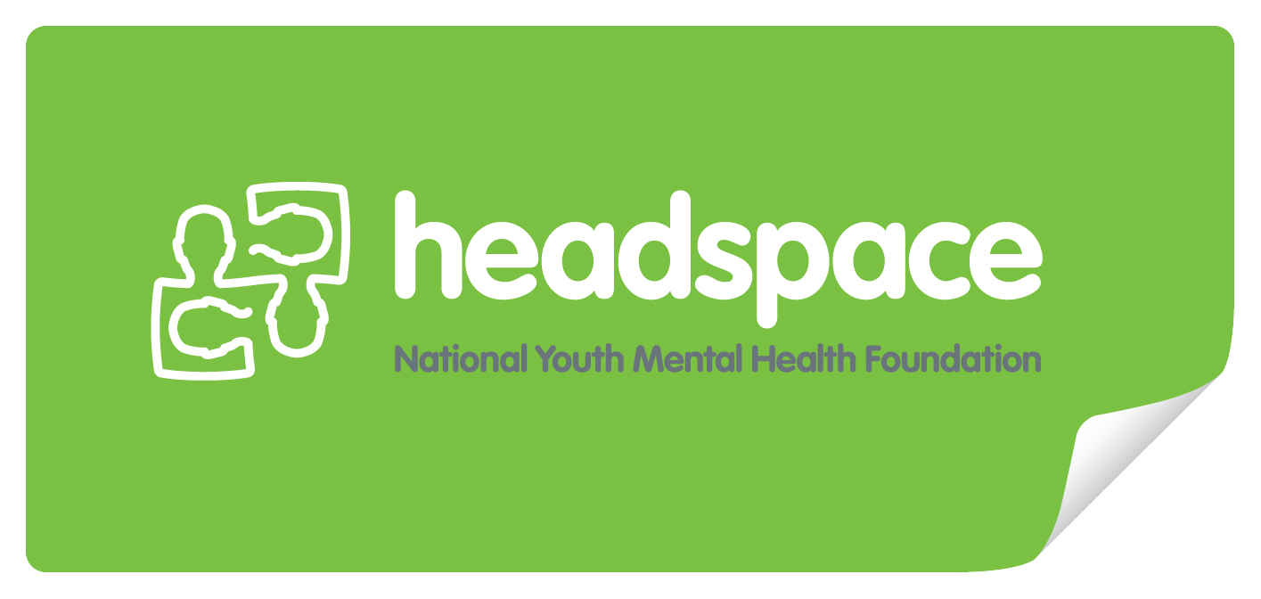

My Career Action Plan
08
Fall

Name:

Date:

A Career Action Plan helps you to focus on your goals and plans for the future. It helps you to work out how you are going to achieve what you want relating to school, work and life. A Career Action Plan lets you work out your career capabilities and how they relate to your preferred career option.

My Profile

Personal characteristics
My current skills and abilities
(Things that I can do well, e.g. listening, team work, problem-solving)
My values
(Things that are important to me, e.g. honest, hard-working)
My interests
My proudest achievement
Self-assessment instruments used and results
(e.g. Career Voyage)

Educational background

Current subjects
Subjects studied last year
Completed certificates/statements of attainment
My preferred learning style
(check the Job Guide ‘Type of Work’ chart)

Employment/Volunteer achievements
Employer / Organisation name | Type of tasks undertaken / positions held

Community involvement
Organisation name | Type of tasks undertaken / positions held

You already have a range of positive aspects about your personality and things you can do which will help you to do well at school and work. In the tables below, tick the top three attributes that best describe you and tick the top three employability skills you do best.

Attributes* | Top 3
Loyalty
Commitment
Honesty and integrity
Enthusiasm
Reliability
Personal presentation
Commonsense
Positive self-esteem
Sense of humour
Balanced attitude to work and home life
Ability to deal with pressure
Motivation
Adaptability

Employability Skills* | Top 3
Communication
Team work
Problem-solving
Initiation and enterprise
Planning and organising
Self-management
Learning
Technology

* The Employability Skills Framework was developed by the Australian Chamber of Commerce and Industry (ACCI) and the Business Council of Australia (BCA) in 2002. For more information please see: http://www.dest.gov.au/sectors/training_skills/publications_resources/other_publications/

I have a career portfolio containing:

- VASS Student Number
- VTAC application
- VTAC SEAS application
- VTAC Scholarship application
- Accommodation information
- List of open days to attend
- Up-to-date resume
- Sample cover letter
- Three referees
- Reference letters
- Certificates/Awards
- Reports/Transcripts
- Statement of Results
- Workplace Learning report
- Art folio/audition prepared
- Employment support contacts
- Educational support contacts
- Tax File Number
- Careers counselling notes

My Future

Date:

How much do you know about different education and training options? Visit the myfuture website (www.myfuture.edu.au) and try the ‘My career profile’. We recommend you complete the ‘Interests and Skills’ activities and then complete the ‘Education and training activity’.
You can then select multiple Suggested occupations.You can view details about education and training options by selecting the Pathways tab after selecting an occupation from the suggested occupations list. You can also view relevant course listings from this page by selecting ‘Find courses related to this occupation’

My career choices
 | First Choice | Second Choice
Choice
Qualities required
Check the “attributes” in:
myfuture: www.myfuture.edu.au
Job Guide: www.jobguide.deewr.gov.au
Duties required
Check the “skills” in:
myfuture: www.myfuture.edu.au
Job Guide: www.jobguide.deewr.gov.au
Potential employers
Employer important dates
(e.g. pre-apprenticeship tests)
Employment outlook
Check out Job Outlook: www.joboutlook.gov.au
Education/training required
(e.g. course name)
Providers offering course
Provider open days and important dates
Course requirements and prerequisites

It’s always a good idea to have Plan B organised in advance. Consider pathways into your first and second choices, and some other possible options relating to further education, training and employment you can undertake.

Pathways and other options
Plan B
Pathways and other options
(e.g. VET provider then university)

My Plan

Date:

Goals are things that you want to achieve in the future. They are things that will help you to be prepared and ready for change at school or in your life. It is important that you think about goals early because then you can work out how to achieve them. Thinking about goals means that you will be prepared to study the subjects you like, do the types of occupations you prefer, and keep your future options open. If you meet a goal throughout the year, set another new one for yourself – maybe a more challenging one.

      - Think about goals that relate to education/training and employment. For example, an education/training goal might be to hand all school work in on time, and an employment goal might be to find a part-time job.
- Think about why the goals you have made are important. For example, handing all school work in on time means you are developing time management skills, and working part-time helps you to develop a school-work-life balance.
- Think about how long it will take you to achieve your goals. Some goals are short-term which means you can achieve them in a few weeks. Some goals are long-term which means it might take a year or more before you can achieve them.

Education and Training Goals
What is my goal? | How will I do it? | Why is it important? | When will I do it by?

Employment Goals
What is my goal? | How will I do it? | Why is it important? | When will I do it by?

Resources I need to help me
Sources of information
(e.g. myfuture, Job Guide, VTAC VICTER, TAFE Course Directory)
Who can help me
(e.g. friends, family, careers practitioner, teachers, etc)

Areas I need to develop to achieve my career choice
Achievement Date
Attributes*
(e.g. personal characteristics such as personal presentation and motivation)
Skills*
(e.g. academic skills and employability skills such as organising, learning and team work)
* A list of attributes and skills can be found in The Employability Skills Framework, developed by the Australian Chamber of Commerce and Industry (ACCI) and the Business Council of Australia (BCA) in 2002. For more information please see: http://www.dest.gov.au/sectors/training_skills/publications_resources/other_publications/

My Review

Date:

Throughout the year it is important for you to spend some time thinking about the goals and plans you set for yourself, and what it was like working out your career capabilities and how they relate to your preferred career option. Reflecting on what you wrote in your Career Action Plan throughout the year, you might need to include some new things in your next Career Action to help you to achieve your long-term goals.

Which goals have I achieved at this stage?
Which goals have I achieved at this stage?

My education/employment goals | When I achieved them
My employment goals | When I achieved them

Which goals need further work?

Goals | People/resources to help me

Have my career choices changed from what I wrote in the ‘My Career Choices’ table in the ‘My Future’ section of this Career Action Plan? Yes No
If you answered “yes”, please re-do the ‘My Career Choices’ table in the ‘My Future’ section to make sure that you are fully prepared to pursue a career in this area.

Comments
Comments from parents, family members, community members, carers, guardians or other trusted adults | Date:  Comments:
Comments from teachers, careers practitioners or other school staff | Date:  Comments:

