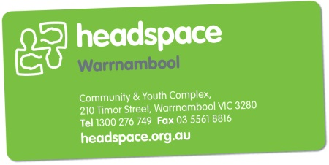

Booking request form for headspace staff to provide training, information sessions and resources

Organisation/school name
Contact person
Phone and email

What would you like headspace staff to provide for your organisation?
Topic/s

Objectives for the session

Preferred date (Please note a minimum of 8 weeks’ notice may be required to plan staff time and resources)

Preferred times
Audience – who are they? How many?

Resources required? (We have a huge range of info sheets, posters and promotional merchandise)

Any special requirements?

Please send to the Community Awareness & Engagement Coordinator headspaceWarrnambool@brophy.org.au phone 1300 276 749 or fax 5561 8816

