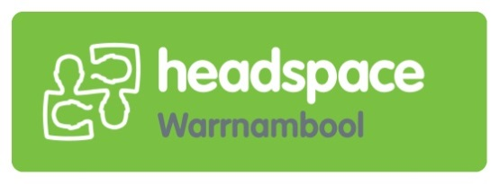

**Young People are invited to join!**

**This group would suit young people aged 12-17 years and aims to provide a safe and fun space to “catch up” with others.**

**The group will be run by headspace Youth Workers and will have activities such as:**

* **social and team building games**
* **art and craft activities including journaling**
* **health and well-being activities**
* **social skills**
* **well-being education**
* **and much more fun stuff**

**The program will be running every Wednesday from 4:00pm to 5:00pm**

**@ Brophy Family Youth Services**

**210 Timor Street**

**For more information, please feel free to contact Caitlin from our Youth Work Team on**

**5561 8888.**

**Please ensure you have had a parent or guardian complete the attached consent form and return it to headspace staff at the next “Catch Up” session.**

**If individual support is required, a referral to the appropriate service will be recommended.**

**All young people will be asked to complete the MDS survey at the beginning of each session (this is voluntary).**

**“Catch Up” Group**