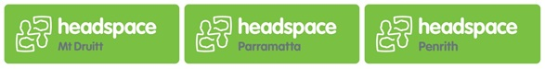
Mental Health Event- Request Form

Please complete this form ONLY if your request is in relation to:

Mental health event - you can invite us to participate in your event (e.g. a festival for Mental Health Month).

Please complete this as a word document and return via email to:
headspaceCDT@ucmh.org.au
We will respond to all requests within two weeks.

Please provide the | following information:
Today’s date: | …………………………………………………………………
Your name: | …………………………………………………………………
Organisation: | ……………………………………………………………….
Phone number: | ……………………………………………………………….
Fax number: | ……………………………………………………………….
Email: | ………………………………………………………………..
Your closest headspace centre: | Parramatta  Mt Druitt  Penrith
Do you wish to join our mailing list? | Yes  No

Mental health event – The Community Development Team can participate in community events and engage in health and service promotion.
We can provide a pop-up stall to distribute a range of information around what mental health is, how to increase positive mental health, and how to link into our services whilst also including some engaging activities for the community.

Please tell us what kind of event you are inviting us to and your expectation of the community development team?

How many young people do you expect to attend the event?

Who will be attending?
Young people (aged 12 – 25)
Parents, family members, or carers of young people
Service providers
Members of the general community
Other (please specify):

On what date and at what times does the event commence and conclude?

What is the expected location of the event?

