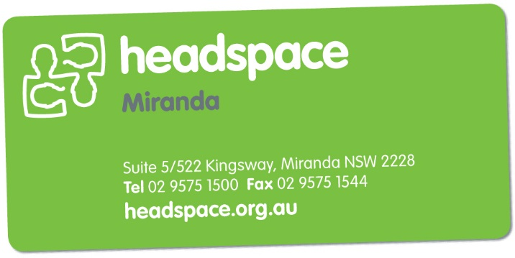
Get Work Ready
Group program- registration form
Please type or write in the boxes below
Personal Information
Name:
Contact number:
Address:
Email
Age (& DOB):
Emergency Contact/Parent
Name:
Mobile number:
Home Phone:
Work phone:
Email:
Relation to young person:

Education and Work Information (please circle)
Currently working: | Yes/No
Looking for work: | Yes/No
Currently studying: | Yes/No
Level of study: | High school/Tafe/Private college/University

Other Information (please circle)
How did you find out about this group? | Website/friend/parent/carer/facebook/school/Tafe  Other (please specify):
I am happy to be contacted for further group programs similar to this? | Yes/No

Once completed please email to headspace.miranda@cesphn.com.au

