Access Key
headspace Hawthorn

Level 1, 360 Burwood Road, Hawthorn, VIC 3122

What is an Access Key?
An Access Key is a document that describes a space and how to access it. They may be used for events to describe features of the venue. In this instance, we have written an Access Key for our headspace centre in Hawthorn. We hope this Access Key helps everyone feel confident to access our centre. We also hope that by having an Access Key, it signifies we take inclusion seriously and encourage people to get in touch about any access concerns.
Access Keys are particularly helpful for people with Autism because it helps alleviate the anxiety associated with going somewhere new. They are useful for people who use wheelchairs because it describes the best way to get to and move around a space.
Access Keys acknowledge that not all spaces are 100% accessible. By sharing this information about what is and what isn’t accessible, young people with a disability have more agency and control over if and how they participate.
If you have any questions at all, or if there are other ways we can improve accessibility for you, please get in touch. By either calling us on (03) 9006 6500 or emailing enquiries@headspacehawthorn.org.au

How do I use this Access Key?
You may want to read this document in full or skip to parts you want more information about. There are pictures throughout the document, with image descriptions that may help you visualise the space.
This Access Key also comes in an Easy Read version. This can be found on our website headspace.org.au/headspace-centres/hawthorn/

Contents
Getting here via car | Page 3
Getting here via public transport | Page 4
Building entry | Page 6
Level one | Page 9
Reception | Page 10
Toilets | Page 11
Counselling rooms | Page 13

Getting here via car
The best place to park is the Kent Street Car Park, which runs off Burwood Road. This is two hour parking for regular car parks. Please refer to the signs in these parks as some are for council staff only. There are three disability car parks in the Kent Street car park, including two directly adjacent to the headspace Hawthorn entrance. These two parks are at the front of the Kent Street car park and are the closest to the entrance.
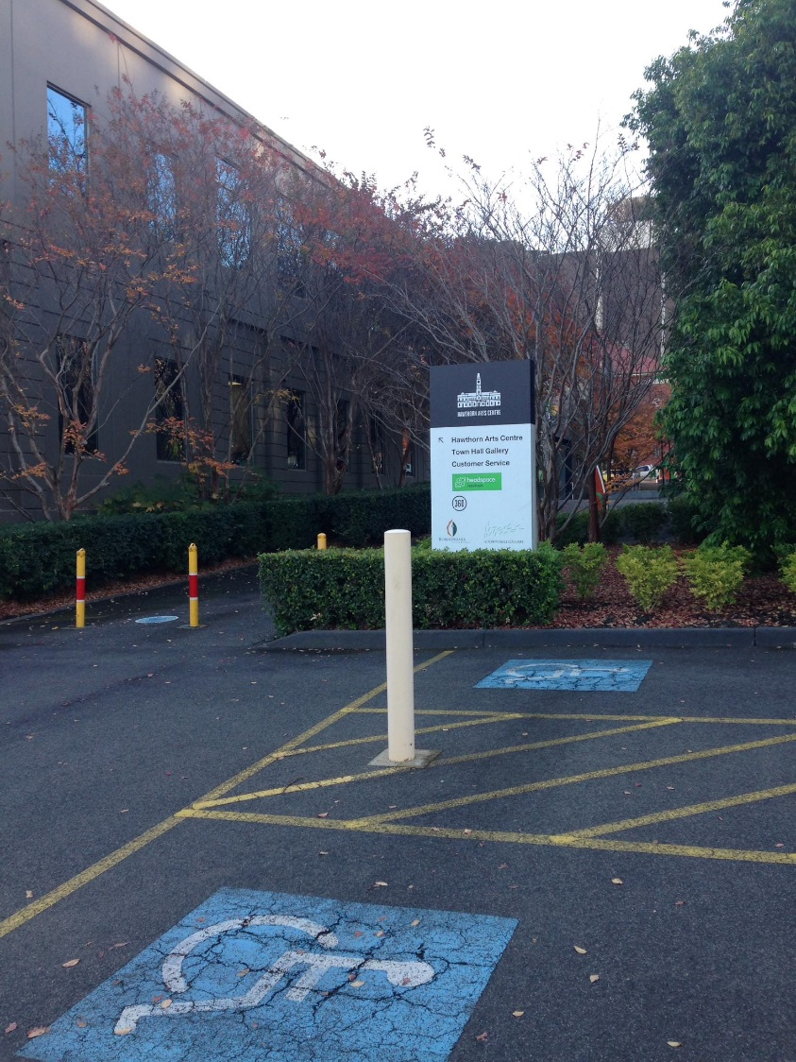

Image description: Two disability car parks adjacent to the headspace Hawthorn entrance. There is a sign with information, small hedges and trees.

The entrance to headspace Hawthorn is approximately 50 meters from these disability car parks. Note there is often gumnuts and twigs on the ground in the carpark.
There are park benches outside in the courtyard area between the carpark and the entry. There is also a smoking area so note there may be odour.
There is more street parking on Burwood road outside the Hawthorn Arts Centre however between 7-9am this is a tow away zone so we recommend parking in the Kent Street Car Park.

Getting here via public transport
The closest tram stop is 73 for the number 16 tram line. This is approximately 150 meters away. Glenferrie station is approximately 250 meters away. If you travel to our centre by tram or train, you will need to cross at the intersection of Glenferrie Road and Burwood road. The intersection is often very busy with foot traffic, cars and trams. Once you cross the intersection, there is a slight incline on the footpath heading East up Burwood road.
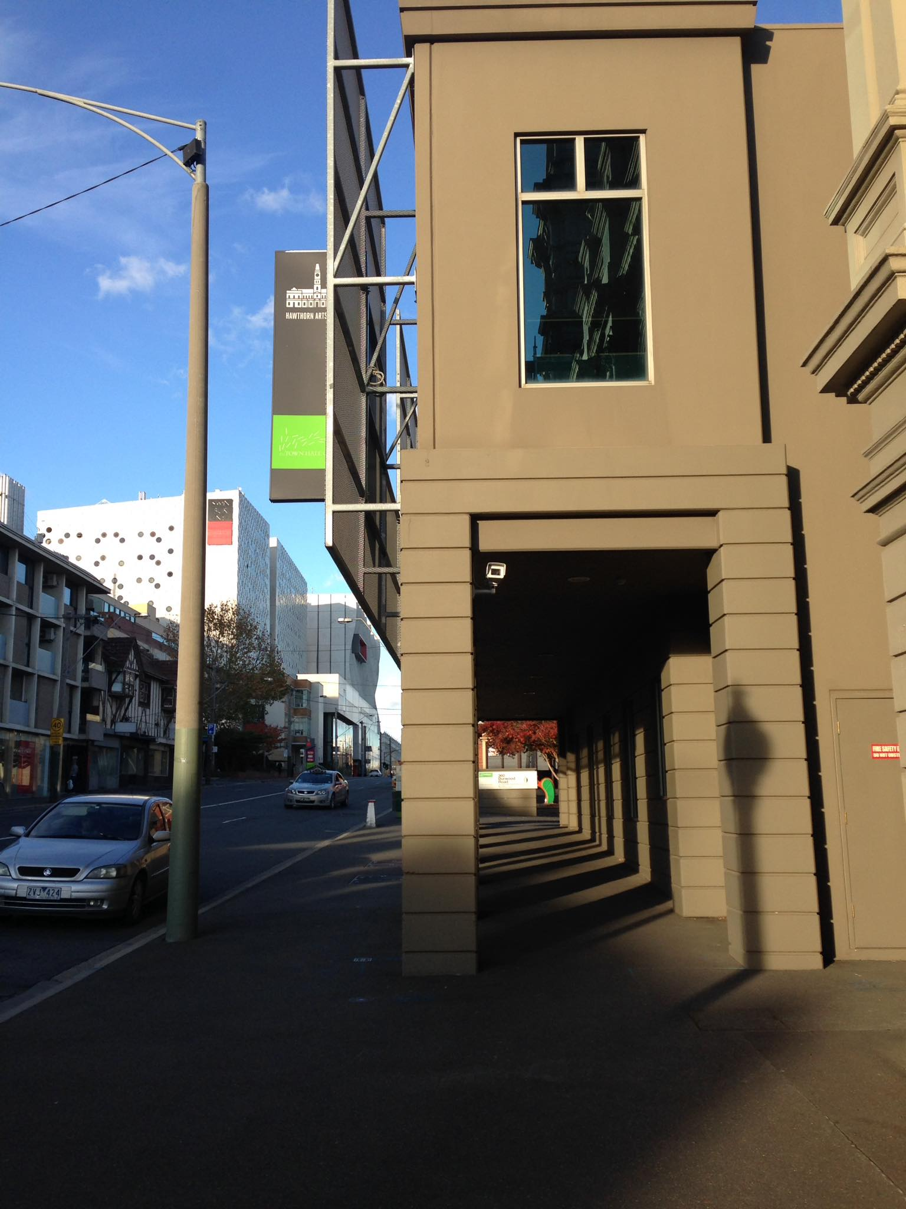
(Image description: The north side of the Hawthorn Arts Centre. A brown cement archway attached to a building. Heading towards Swinburne Uni which can be seen in the distance on the left side of Burwood Road. Walk this direction to get to headspace Hawthorn)

Keep walking this way (East up Burwood road) until you see this sign pictured. On your right, you’ll see an open courtyard like space and a paved area. This is the entrance to our centre.

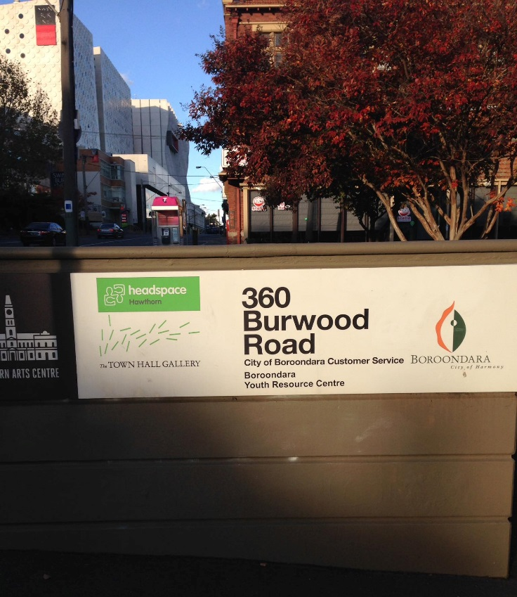

(Image description: White sign on a pillar saying ‘360 Burwood Road, City of Boroondara Customer Service, Boroondara Youth Resource Centre and headspace Hawthorn)

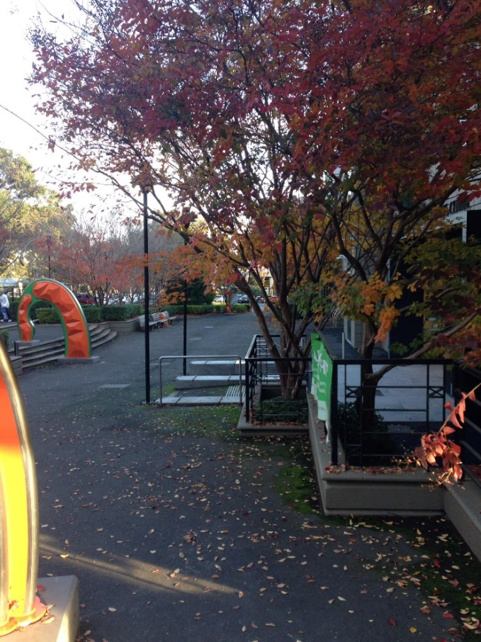

Image description: This is the open courtyard space that leads to the entrance. There is large orange and green sculptures, trees and a paved area. This paved area leads to the entrance of our centre.

Building entry
The building entrance has the option of two steps down with tactile paving and handrails. The ground is tiled here and it can be slippery when wet. There are two glass doors to this entry, you want to use the one on the left. You will notice a large green headspace sign and Boroondara Youth sign. The doors are automatic. If for any reason they are not opening or, you’d like assistance from this point please call us on (03) 9006 6500.

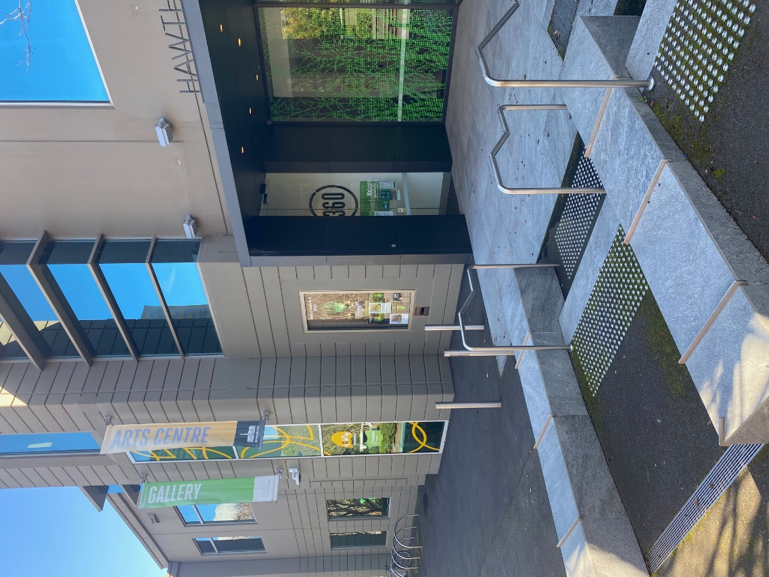

Image description: The entrance point to the building that opens up into the courtyard space. There is two stairs with tactile pavers and hand railing here or, to the left there is a flat entrance that very slightly declines towards the door to headspace.

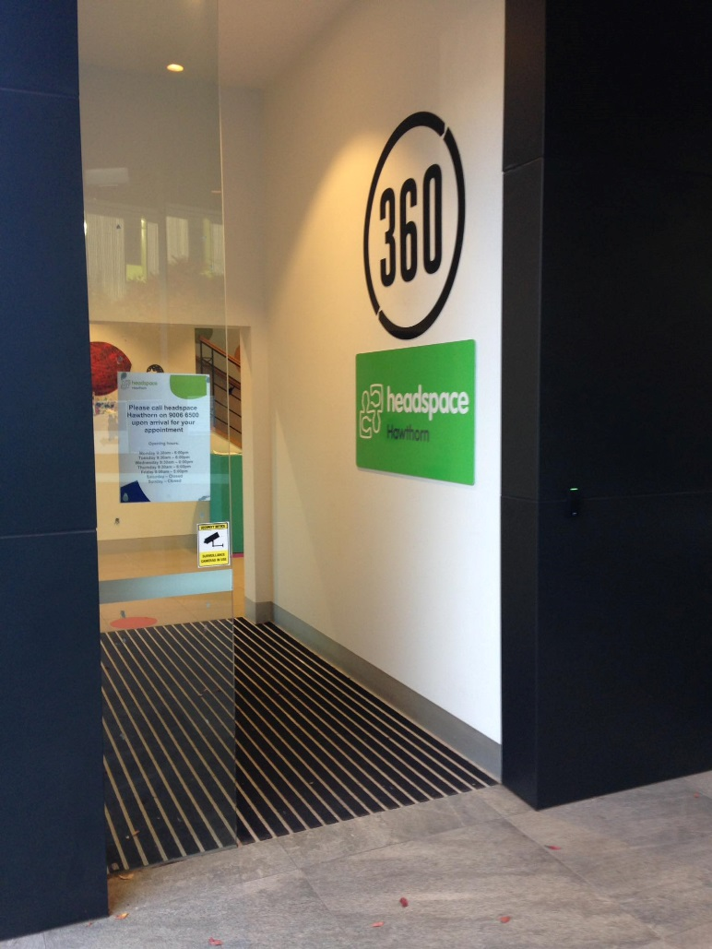

Image description: The automatic glass doorway entrance to headspace Hawthorn. There are two signs on the wall, a green headspace logo and a Boroondara Youth logo. The ground is a semi carpeted texture before changing back to tiles.
This will lead you into the foyer, which is tiled. There is an art gallery in this space called ‘Gallery of Young Art (GOYA)’ there is often expressive and colourful artwork in this space. This space has a high ceiling and a combination of natural and artificial lighting.
There is an elevator in this foyer, on your right as you come in. You can use this elevator, or the stairs get to level one. There are 27 stairs to level one, separated into three levels all with tactile paving and hand railing.

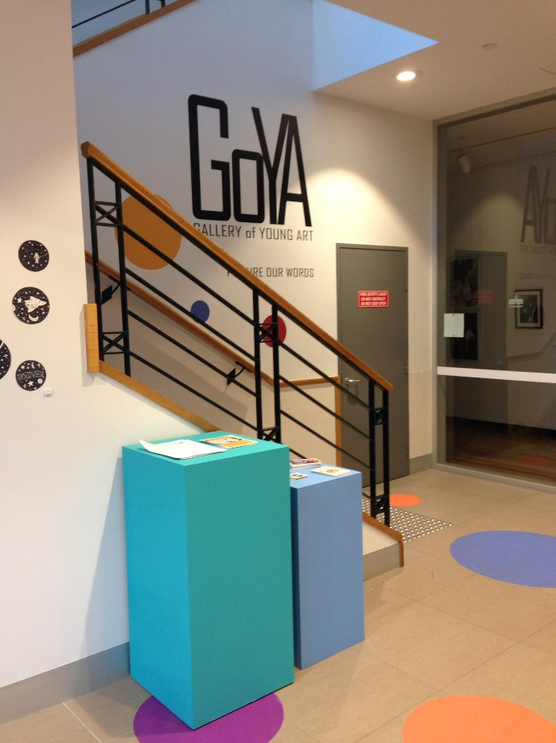

Image description: The staircase up to level one. This area is often decorated with artwork. There is a large sign that reads ‘GOYA Gallery of Young Art’. Note the artwork and colours may look different to what is pictured.

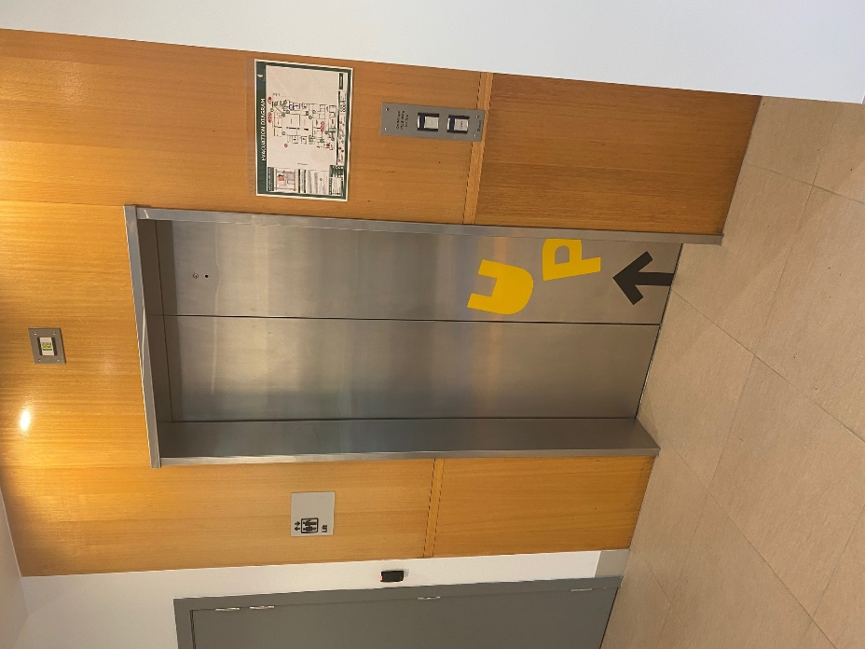

Image description: There is an elevator on the ground floor, to your right as you enter the foyer. This will also take you to level one.

Level one
Level one has a general foyer area with three doorways. The first one on your left is for Boroondara Youth, the middle door is a board room with frosted glass and the door on your right is for headspace Hawthorn. The light in the foyer is mostly natural with some artificial. There is a quiet space with plants and a bench or beanbags in this foyer area. Note there is often music playing or the sounds of people playing video games at Boroondara Youth. Level one foyer area is all carpeted.
The glass entrance to headspace Hawthorn is decorated with large colourful shapes. The doorway to headspace is 88cm wide and can be extended to 122cm wide.

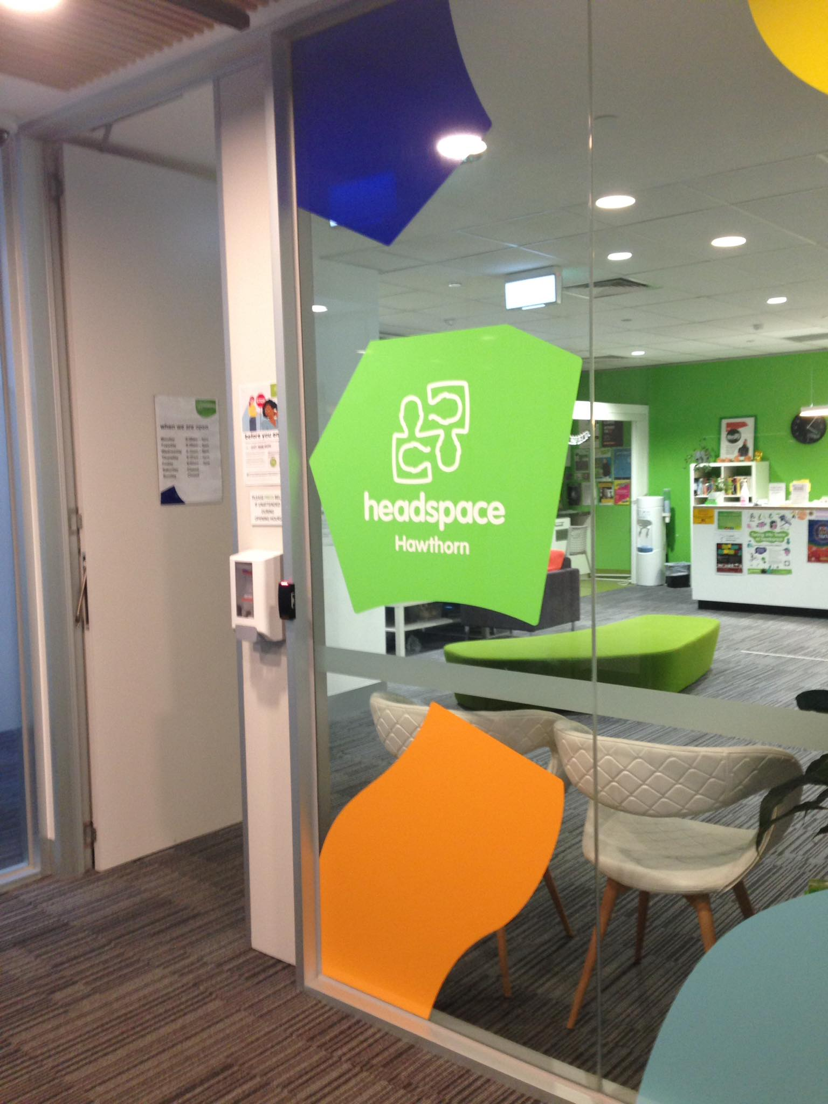

Image description: The glass windows looking into our centre are decorated with large colourful shapes including a large green headspace Hawthorn logo. The door is usually open for you to walk in.

Reception
The reception area is carpeted and has all artificial lighting. It is quite bright, however the large light over reception can be turned off. The main wall behind reception is bright green while the other walls are more neutral. There are various pictures and posters on the walls.
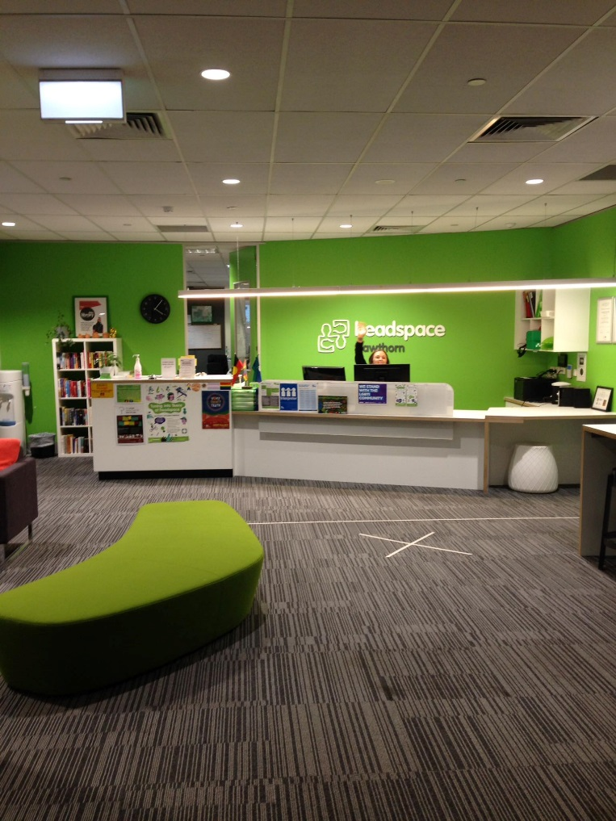
Image description: This is the reception area at headspace Hawthorn. There are a number of colourful couches. The reception desk is straight ahead in front of a green wall with our logo sign.
The reception desk is low and the reception staff are visible from a seated position such as a wheelchair.
There are a number of seating options including arm chairs, a couch against the wall and a large ottoman style green couch. There is enough space here to fit a wheelchair.
The TV or music is usually playing at a reasonable volume. The sound of the phone ringing can also be heard. There is never too many people at one time in the waiting room, however people do come and go.
There is a watercooler with disposable cups which you are welcome to help yourself to. Again, if you need assistance with this, staff are happy to help. There is also a small kitchenette for young people to use to make themselves tea. The bench is 90cms from the ground.
Reception may ask you to complete you headspace survey on an iPad when you arrive. The iPad has accessibly settings which can be turned off if required.

Toilets
There is a gender neutral disabled toilet in the reception area as well as three other gender neutral toilets. The disabled toilet is on the right as you enter reception and the other toilets are on the left. The doorway of the disabled toilet is 92cm wide and the sink is 82cm off the ground. There is hand railing in here too.
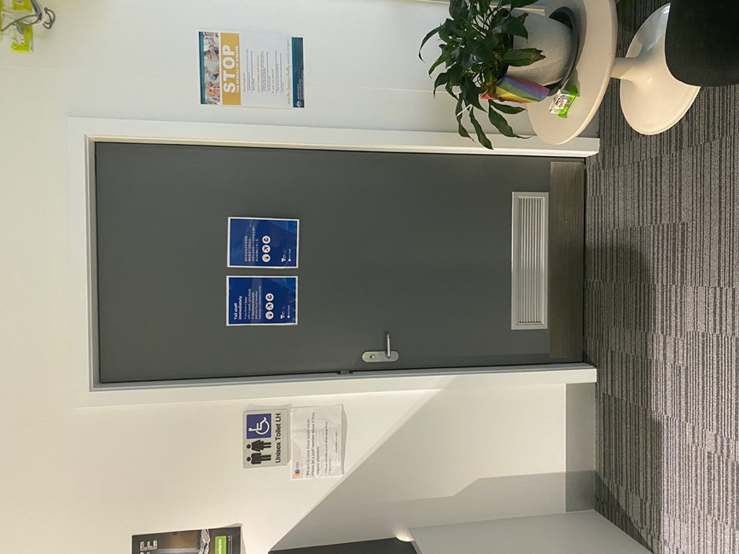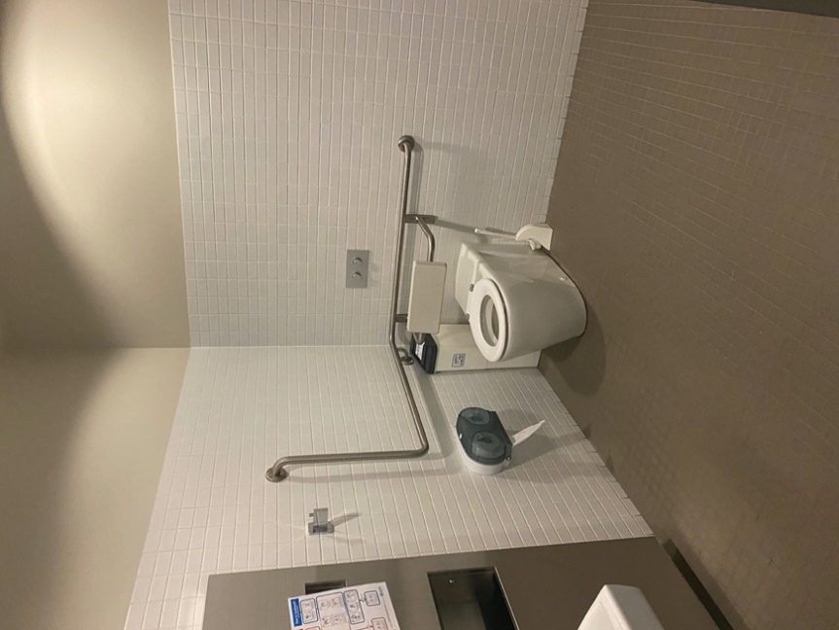
Image description: A toilet with hand rails is in the corner of a room. The floor has brown tiles and the wall has white tiles. There is a toilet roll dispenser hung low next to the toilet.
Image description: A grey door with a sign next to it that reads, “Unisex Toilet LH”. There is carpet at the entrance of the door.

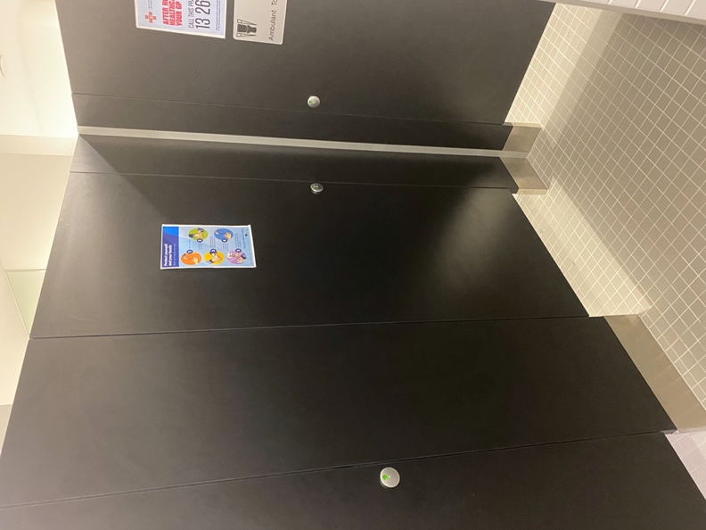
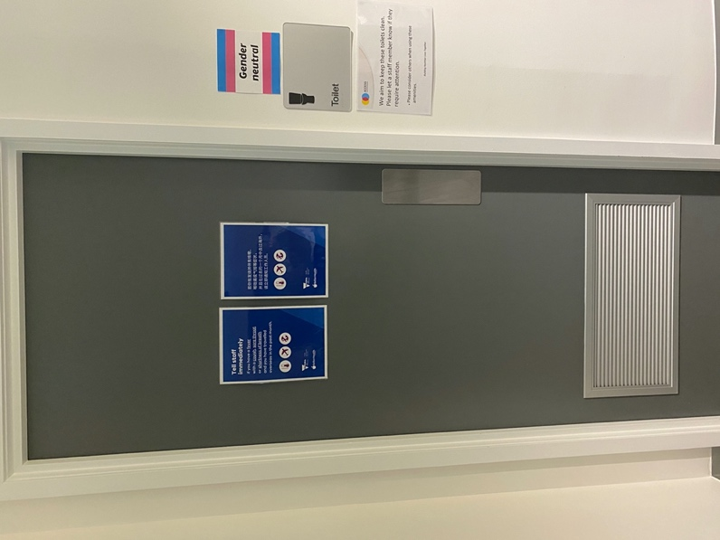

Image description: A grey door with a sign next to it that reads, “Toilet”. There is also a blue, pink and white sign that reads’ “Gender neutral”
Image description: 3 black toilet cubicle doors. The doors do not have handles. The floor is tiled.

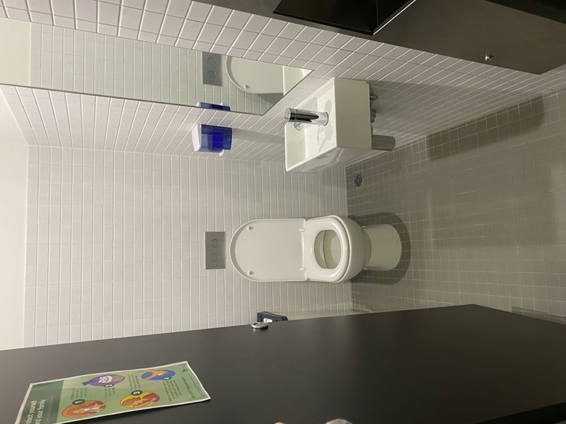

Image description: A cubicle with a black door open. There is a toilet at the back with the flush buttons above it. There is also a sink on the right with a mirror and soap dispenser.

Counselling rooms
The doorway that leads to where the counselling rooms are, is 88cm wide and can be extended to 122cm wide. The hallway that leads to each counselling room is over 1 metre wide. Each room is slightly different in colours and lighting. Most rooms have at least one window for natural light. There is one room that has no windows, only artificial lighting.
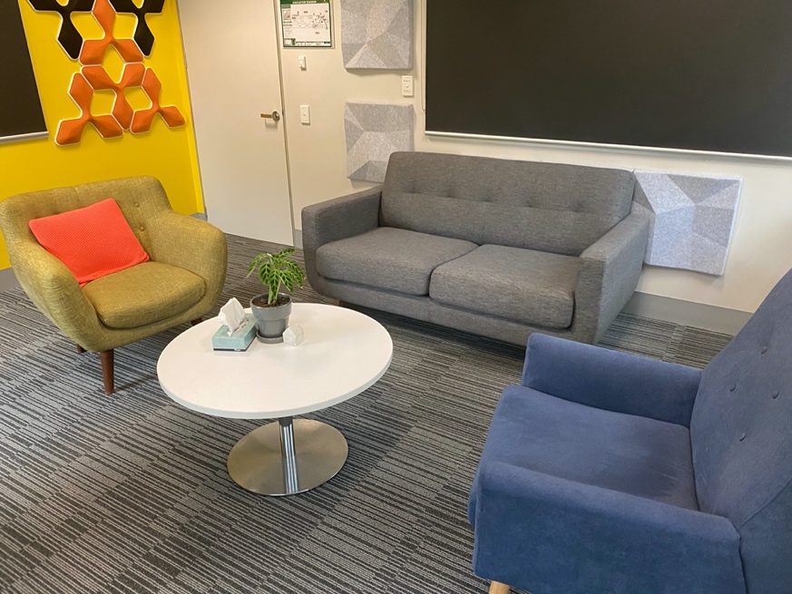
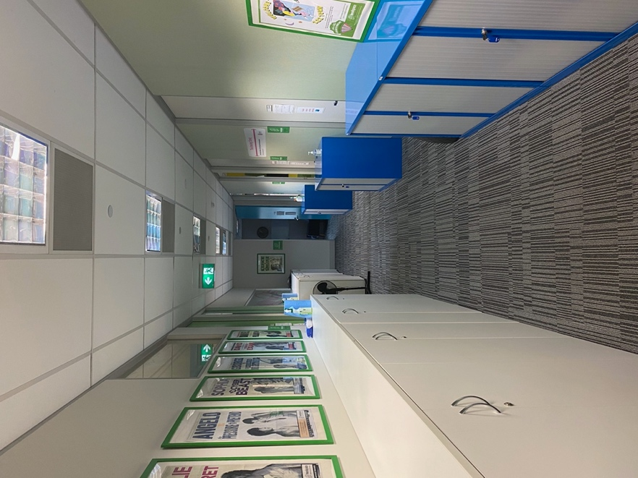
Image description: A room with 3 couches. 2 of the couches are for one person and 1 is for 2 people. There is a small white table and grey carpet floors. One wall is bright yellow with orange and black shapes on it.
Image description: A hallway with grey carpet floors. The walls are painted a light green and there are cabinets on either side of the hallway. There is a green exit sign around halfway down the hallway.

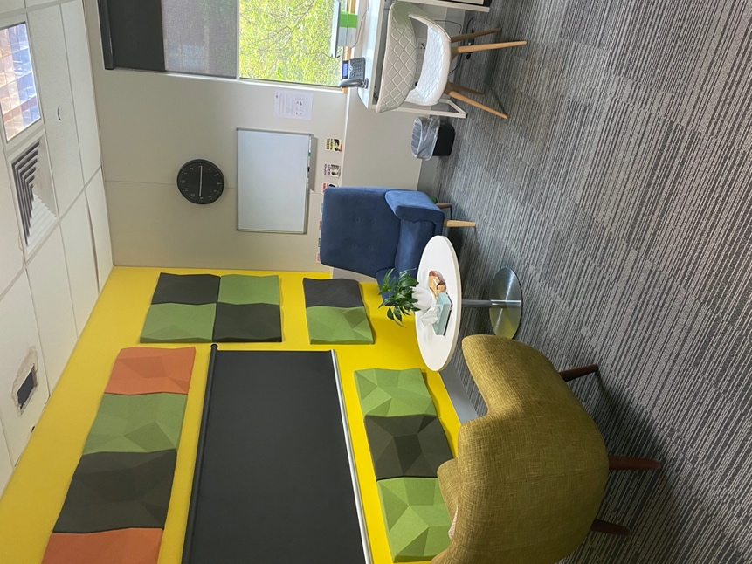
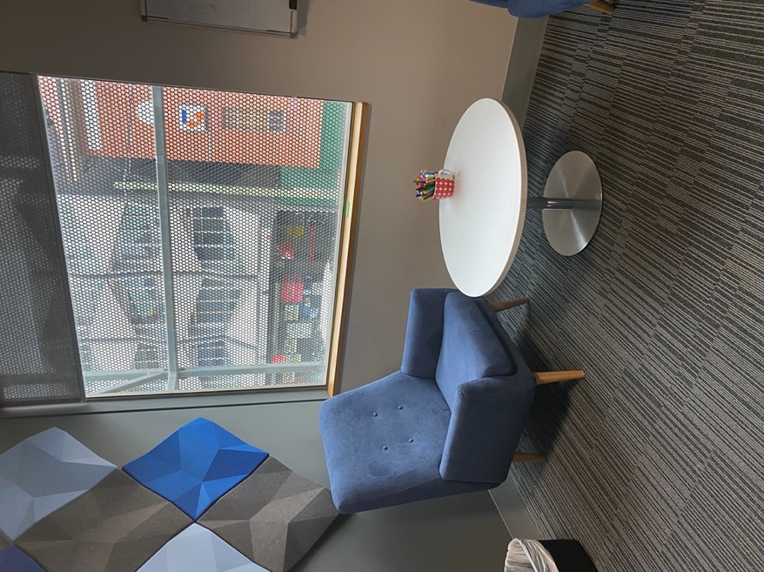
Image description: A room with 2 chairs and a small white table. The room has grey carpet and one window. One wall is a bright yellow with orange, black and green squares on it
Image description: A room with 1 chair and a small white table. There is one window and the wall is grey with blue and grey diamonds.

