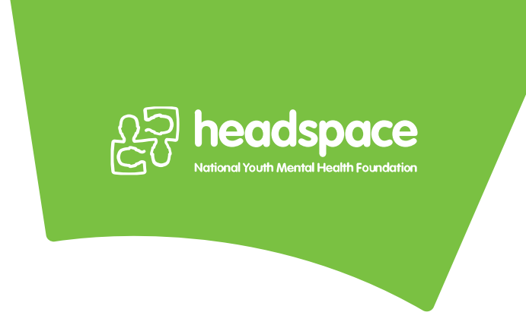
Are you looking to follow your passion, have a new challenge and work within an exciting team?
headspace is the National Youth Mental Health Foundation and provides early intervention for young people aged 12-25 years with mild to moderate mental health issues.
headspace Gosford currently has opportunities for private practitioners to work within a multi-disciplinary team offering mental health, physical health, drug and alcohol services as well as support with employment and education. We are collocated with other support services at the Gosford site.
We offer:
- Flexible work days and hours, scheduled around your commitments
- Administrative support including reception, billing and general administrative support
- Support from the multi-disciplinary team as well as support from other collocated partners (including GP; Psychologists; Clinical Psychologists; Employment Support; Drug and Alcohol Workers, and Social Workers)
- Paperless practice with IT support
- Ongoing referral base from our General Practitioners onsite of young people who have been assessed by the Youth Access Team and who are ready to receive services
We are looking for clinicians eligible to provide services under Medicare who are/have:
- Registered Psychologist or Clinical Psychologist
- Mental Health Accredited Social Workers
- A commitment to delivering allied health services as an integrated part of a multidisciplinary team
- Experience providing therapy to young people 12-25 years
- An ABN and personal Professional Indemnity Insurance
- To hold a Medicare Provider Number issued by Medicare Australia and be registered with Medicare and be willing to bulk bill
- To hold all relevant current licenses, registrations and memberships for legal practice as a qualified and registered professional within the state of New South Wales.
- Child related employment and criminal record check
- A high standard of professionalism and a willingness to use the headspace record keeping and data collection systems
Those interested can contact the headspace Gosford and Lake Haven Manager
Helen Isenhour on 0434 567 265 or Corrina Niven, Practice Manager on 4304 7870.

