Impromptunes is Melbourne’s finest improvisation group. Using teamwork, active listening and communication, this group is capable of providing completely improvised musicals from scratch.
The troupe has been met with critical acclaim both statewide and nationally. The experienced ensemble, with many members who are alumni of VCA, WAAPA and Impro Melbourne, runs performances and workshops for students and adults alike throughout Melbourne.
Impromptunes has developed many educational programmes for students, which can be tailored to suit the needs of the group. Regardless of the format, the common factor in their workshops is always being fun!
Impromptunes love sharing their passion for improvisation and music with younger learners, and particularly enjoy providing students with an opportunity to come out of their shells and experience something that is not often available in schools.

Roland Lewis, Facilitator
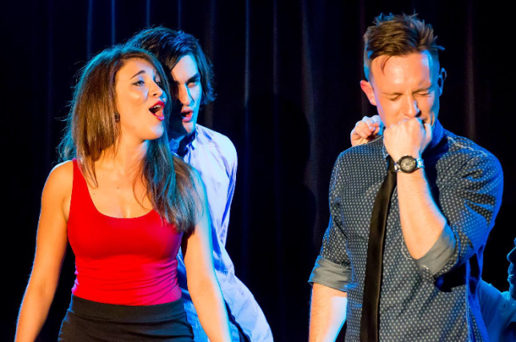
Roland is a qualified teacher who studied improvisation with Impro Melbourne. He has a wealth of performance experience, performing as an ensemble member at Impro Melbourne, The Big Hoo-Haa, The Impro Box and Impromptunes. Roland runs improvisation workshops privately as well as for Impromptunes.

Roland’s workshops for beginner improvisers focus on fun, listening, taking care of your scene partner and overcoming/embracing fear. Through a series of group based games and exercises, students will learn to create scenes from a single suggestion while developing the fundamental skills for good improvisation.

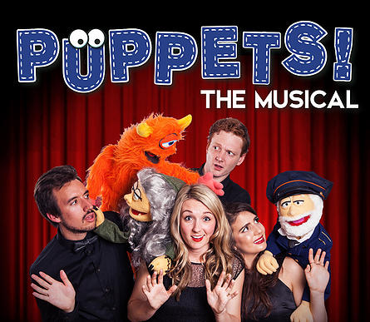

Improvised. Puppet. Musical.

In Melbourne Fringe 2015, Impromptunes presents its never-before-seen 'puppetry of the pianist', for your viewing delight! The talented folks at Impromptunes are teaming up with The Puppet Box to present a completely unique, completely improvised show.

In Puppets! - The Musical - nothing is planned. Watch in astonishment as these exciting performers create a musical that is quite literally hand-made in front of your very eyes.

The season runs from 16 September to 4 October (excluding Mondays and Tuesdays) 7pm at The Butterfly Club, 5 Carson Place. We are planning on going to the performance on September 30, with a special Q and A for workshop participants afterwards.

Email or phone Ellen at headspace Bentleigh to reserve your spot! e.kang@alfred.org.au or 9076 9400

