Camperdown

welcome pack for

family, carers, and friends

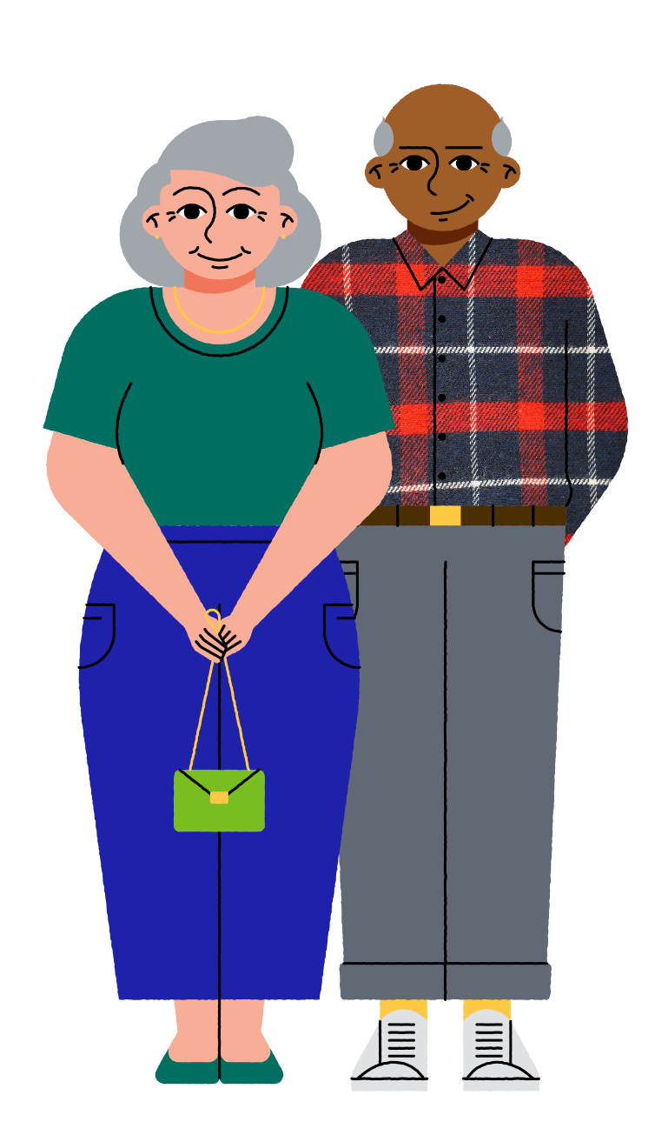

headspace Camperdown
Level 2, 97 Church Street
Camperdown, NSW 2050

(02) 9114 4100
headspace.camperdown@sydney.edu.au
headspace.org.au/headspace-centres/headspace-camperdown/
@headspace_camperdown

Opening hours
Mon to Fri: 8:30am – 5:30pm
Sat and Sun: Closed

centre location and accessibility
headspace Camperdown is located in the Brain and Mind Centre at the University of Sydney. Enter at 97 Church Street and then take the lift or stairs up to level 2.

Address: Map:
Level 2, 97 Church St
Camperdown NSW 2050

https://goo.gl/maps/PJgYPYsbYUuvjZXz6

Access:
- Wheelchair accessible entrance
- Lift
- Accessible/unisex toilets
- Braille sign
If you have any specific accessibility needs, please let us know prior to your first appointment at headspace Camperdown so we can be aware of how to best assist.

Public transport:
We recommend getting here via public transport as street parking is limited.
By bus: There is a convenient stop on Parramatta Rd near the corner of Mallett Street.
By train: Newtown is the closest train station. It is about a 15–20-minute walk.
Plan your trip here transportnsw.info/trip/

Parking:
Limited 2hr street parking is available on Church Street and in the surrounding streets.

welcome to headspace
headspace is a family, carers, and friends inclusive service. We believe that you play an important role in your young person’s journey to better wellbeing. We also understand that family and friendships can take many different forms, including:

All types of families: | All types of caregivers: | Significant others:
nuclear  extended  blended  single-parent  heterosexual  same-sex couples. | parents  partners  foster carers  grandparents  god-parents  adoptive parents  other family members guardians | friends  teachers  mentors  kinship  sibling relations  spiritual care leaders

We know from research that involving families in a young person’s care can lead to better health outcomes. Wherever possible, we will support and create meaningful opportunities for you to directly participate in our services.

How you can be involved will depend on many things – including your young person’s age, life experience and their feelings about family involvement.
We encourage family, carers, and friends involvement and respect the privacy and confidentiality of young people.

This pack will introduce you to our service where you can find further information and support for you and your young person.
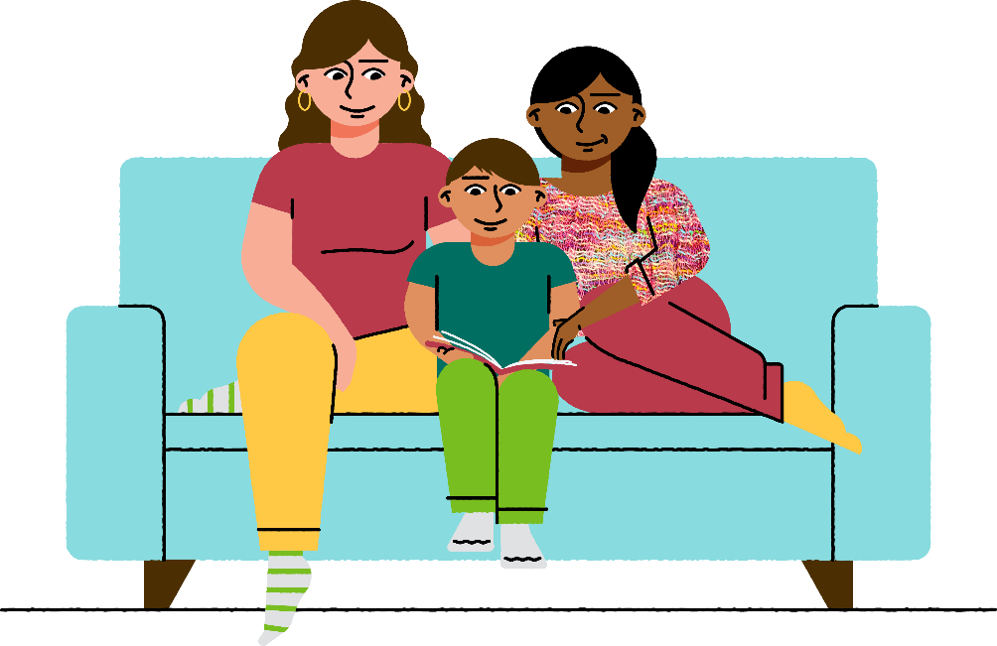

How can we help?
headspace is the National Youth Mental Health Foundation. headspace provides information, support, and services across four key areas which may affect a young person’s health and wellbeing:

Mental health
We can help young people if they’re:
- Feeling down, stressed or worried
- experiencing relationship problems or difficulties with your family or friends
- wanting to talk about sexuality or gender identity
- just not feeling yourself, or if you’ve noticed changes in your thoughts, feelings or behaviour.

Physical and sexual health
Many headspace centres have youth-friendly doctors and nurses who can assist young people with:
- any physical health issues
- contraception and sexual health advice.
If your nearest headspace centre doesn’t have a doctor or nurse, they can still recommend a youth friendly doctor in your area.
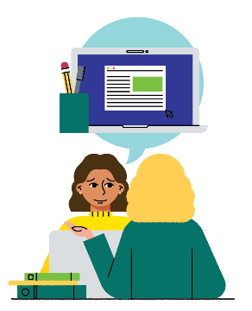 | Work, school, and study  We can help young people if they’re:  - struggling at school or work and feeling anxious or stressed  - unsure of what course you want to do  - needing a hand writing a resume  - searching for a job.

Alcohol and other drugs
Alcohol and other drugs can affect things that matter to young people, and also to their emotional, physical and mental health. It can impact on their work, their study and the relationships in their life. If a young person is having a hard time stopping, or cutting back, we can support them with:
- developing a plan to tackle their challenges
- connecting with supports, including professional help like GPs and counsellors
- identifying triggers and provide them with tools and advice on how to avoid them.

headspace resources and services

headspace centres
headspace centres provide young people with access to a range of health workers who have specific expertise in working with young people – including doctors, psychologists, social workers, alcohol and drug workers, counsellors, vocational workers, occupational therapists, and youth workers.
Young people can make an appointment at a centre in person or by phone or email or ask a friend, family member or health worker to make an appointment on their behalf.
The headspace centre service model is tailored to young people's needs – providing services that are developmentally appropriate, suited to the stage and complexity of illness, comprehensive, evidence based and quality assured.
The headspace model works on a multidisciplinary team approach. Information may be shared across teams about a young person to ensure they're receiving the most suitable care for their needs. This approach also ensures young people are not having to retell their story.
Please note: headspace provides time-limited services for mild to moderate difficulties. It is not an emergency service. If you need immediate support or medical assistance contact:
Emergency services 000
Lifeline 13 11 14
Kids helpline 1800 55 1800

headspace website
The headspace website is the place to find information about mental and physical health, work and study, drugs and alcohol and how to get help. To access the headspace website visit headspace.org.au.

eheadspace
eheadspace is a national online and phone support service for people aged 12–25, their families and friends. eheadspace is staffed by experienced and qualified youth mental health professionals.
Web-chat and phone support operates from 9am – 1am (AEST), every day of the year. All they need to do to access eheadspace is create an account at headspace.org.au (for web-chat or email support) or call 1800 650 890.

Digital work and study

headspace Work and Study is an online and phone support service for people aged 15–25 years who need support with work or study. It is staffed by work and study specialists.
The service operates within business hours, and we will try and find an appointment time that works for the young person.
To access the Work and Study service, all they need to do is register at headspace.org.au/workandstudy (for web-chat and email) or phone 1800 810 794.
All Work and Study services are free, but if they call from a mobile the usual call charges will apply.

Career mentoring

Career Mentoring is an online and over the phone service that connects young people aged 18-25 with an industry mentor in their field of interest. Mentors work with young people to help them find, maintain and enjoy work.
Mentoring occurs every two weeks, for up to six months.
To register their interest in Career Mentoring, they can visit headspace.org.au/mentoring
All Career Mentoring services are free. If a young person is connecting with their mentor by phone, they will be given a toll free number to call.

what happens when a young person visits a headspace centre?

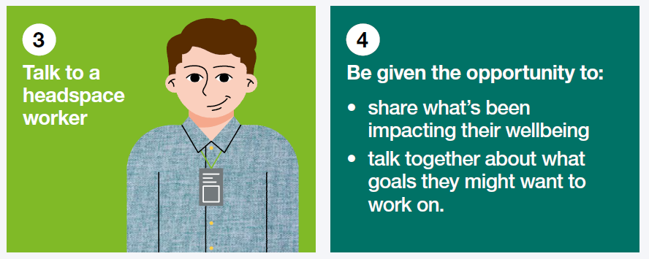
The first visit:
If your young person feels comfortable, family members are welcome to attend.

After the first visit:
If your young person chooses to continue at headspace, together we might work on goals they’ve identified as important to them. We would work together to plan the next steps which may include:
Brief intervention and problem solving with a qualified clinician
Early intervention and supportive counselling with one of our clinical team
Access to a doctor and/or mental health nurse for physical or mental health difficulties
Study or vocational assistance with a work and study specialist
Referral to other agencies best suited to the young person and/or family’s needs. If the young person needs referral from a doctor to access a particular service, headspace can arrange this

How long will an appointment take?
Appointments usually last 50 minutes to an hour. Sessions with a GP might be shorter. Initial appointments with our psychiatry registrar can take up to 90 minutes.

services at headspace Camperdown

General practitioner (GP) services
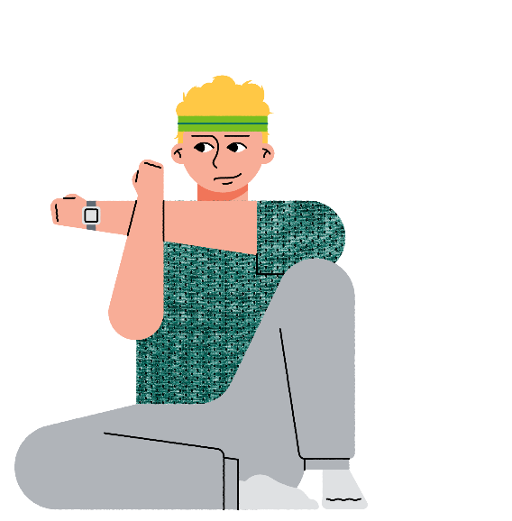
GPs are medical doctors who can help with a wide range of health issues, including physical, sexual, and mental health concerns and healthy lifestyle advice.

Exercise physiology
Exercise physiologists provide individual exercise plans for chronic physical and mental health conditions.

Psychiatry registrar assessment
Psychiatrists are medical doctors who specialise in mental health. A Psychiatric Registrar is a psychiatrist at the final stages of their training and can do much of what a psychiatrist does. The registrar is supervised by the more senior psychiatrist. An internal referral by the headspace multidisciplinary team is required to see our psychiatry registrar.

Group programs
headspace Camperdown offers several group programs – Art Space, Active Group, Q-Group for LGBTIQA+ young people, Unstuck therapy program, CONNECT (social anxiety) program, Neurodiverse Social Group, and Family & Friends Group. See our group program schedule attached at the end of this document or ask reception for further information.

Brief intervention
Up to five sessions of therapeutic intervention targeting specific goals with headspace clinicians (psychologists, social workers and other allied mental health clinicians).

Psychology
We can offer 6-10 psychology sessions with our psychology students, Medicare (MBS) or our Psychological Support Services (PSS) clinicians.
Please note that psychology sessions at headspace are in high demand and waiting times to commence with a psychologist range from one month to four months from the time a receive the valid referral and mental health care plan from the young persons’ GP.
For this reason, the Youth Access Clinician may provide the young person with other no-cost or low-cost options for psychology outside of headspace to ensure that they can access affordable psychological support in a timely manner.

Youth Law Australia
headspace Camperdown has partnered with Youth Law Australia to provide free general legal advice to young people around legal questions including employment, tenancy, education, and some criminal matters.

Family therapy
Our Family Therapist is a trained family and relationships counsellor with Relationships Australia. They can assist families to better communicate and explore difficult issues. They can also help families to make changes to support each other more effectively.

how can I support my young person while they are waiting for an appointment?
We understand that wait times for appointments may vary. While your young person is waiting for an appointment, here are some ways you can support them:

Supporting their mental health
As a parent, carer or friend you can play an integral role in supporting your young person’s mental health and wellbeing by:
- keeping communication open and show empathy for their experiences
- making yourself available whilst also allowing them their own space
- spending time with them
- taking an interest in their activities, and encourage them to talk about what’s happening in their life
- taking their feelings seriously
- encouraging and supporting their friendships
- encouraging activities that promote mental health, such as exercise, good eating, regular sleep and doing things they enjoy
- giving positive feedback
- letting them know that you love them. They may not always admit it but this is likely to be very important to them.

Family, carers, and friends group
This centre holds a free online support group for family, carers, and friends that is facilitated by a headspace worker. Each session, a speaker will cover a different topic related to mental health and facilitate discussion around it. The group is held over zoom roughly every 6 weeks.
For further information or to sign up to this group, please email headspace.camperdown@sydney.edu.au.

Share the responsibility
If possible, share the responsibility of supporting your young person with other members of your family – it doesn’t have to be solely your job. If it isn’t possible in your immediate family, maybe there are people in your extended network of family and friends who can help. The saying “it takes a village to raise a child” is about the power of a shared commitment to care and support a young person.
How can I contribute to headspace?
Family and friends’ involvement in the delivery of our services is important to us. If you would like to provide input into how we engage with family and friends as a service, please speak to a headspace worker.
Family and friends involvement in care can help improve treatment outcomes for young people. The level of involvement will be guided by the young person’s wishes and the services available at your local headspace.
Types of involvement may include:
- supporting a young person to book and attend appointments, attending some sessions with the young person should they consent to this
- attending a psychoeducation or peer support session for family and friends
- having the option of checking in with the headspace worker if you have any concerns or issues.

family, carers, and friends’ rights and responsibilities

Family, carers, and friends rights:
- To have the option of receiving information, education, and support to facilitate your care and support roles
- To be informed in a clear and open way about the availability of services, waiting times, associated costs, and options for your young person’s care and support
- Have your rights to privacy and confidentiality respected by all workers at headspace Camperdown
- To make a complaint and have your concerns dealt with fairly and promptly, and without fear of compromising your young person’s treatment or care
- To be involved in your young person’s care at headspace Camperdown should they nominate so
- To receive support and resources for your own difficulties that may be generated through the process of supporting, caring for or acting as an advocate for the young person
- To provide information concerning family relationships and any matters relating to the mental state of the young person to headspace Camperdown.

Family, carers, and friends have the responsibility to:
- To disclose relevant information that may affect the health care services that we provide to the young person
- To treat staff and other people within the service with respect and dignity
- Notify us, within a reasonable timeframe, if you need to cancel or reschedule your young person’s appointment (with their consent)
- Respect the privacy of others you may come in to contact with in your interactions at headspace Camperdown
- Respect your young person’s and your own health safety and welfare, and that of others.
- To consider the opinions and skills of the headspace workers who provide assessment, support, care, treatment, recovery and rehabilitation services to your young person

More information:
Australian Commission on Safety and Quality in Health Care. (2008). The Australian Charter of Healthcare
Rights. Retrieved from https://www.safetyandquality.gov.au/consumers/working-your-healthcare
provider/australian-charter-healthcare-rights

Australian Commission on Safety and Quality in Health Care. (2017). National Safety and Quality Health Service Standards (2nd edition). Retrieved from https://www.safetyandquality.gov.au/publications/national-safety-and-quality-health-service- standards-second-edition/
Australian Psychological Society. (2015). Charter for clients of APS psychologists. Retrieved from https://psychology.org.au/getmedia/5fb479bb-4ab8-49f3-a9eb-1a76a3779ef4/aps-charter-for
clients.pdf
Commonwealth of Australia. (2010). National Standards for Mental Health Services 2010. Retrieved from https://www.safetyandquality.gov.au/our-work/mental-health/national-standards-in-mental-health
Commonwealth of Australia. (2012). National Mental Health Statement of Rights and Responsibilities 2012. https://www.health.gov.au/sites/default/files/documents/2021/04/mental-health-statement-of-rights
and-responsibilities-2012.pdf
The Royal Australian College of General Practitioners (RACGP). (2015). The RACGP General Practice Patient Charter. Retrieved from https://www.racgp.org.au/running-a-practice/practice
standards/general-practice-patient-charter

consent for treatment
headspace Camperdown is a voluntary service. Health workers can only provide treatment to young people who give consent. This is something we will ask you when you attend.
If the young person is under 18: A parent or legal guardian is the appropriate person to give consent to access our service. The law presumes that people have capacity to make decisions about their health care at 18 years of age. In South Australia it is 16 years.
However, before reaching this age young people can develop the capacity to make decisions about their health care. Capacity to consent relates to the specific decision. While a young person may be competent to make some medical decisions, it does not mean they have the capacity to make all medical decisions independently.
Some young people can consent to treatment without parental permission and are known as mature minors or have Gillick Competence.
Generally, if you are 14 years or over, your parents cannot see your health records, unless you agree to this.
www.health.nsw.gov.au/kidsfamilies/youth/Factsheets/youth-friendly-confidentiality.pdf
www.avant.org.au/Resources/Public/Children-and-consent/
If you would like a copy of our Consent Policy, please speak to a headspace worker.

Confidentiality and our duty of care
When a young person talks to a headspace worker, nothing they say can be passed on to anyone else without their permission unless the young person:
is at risk of harming themselves or someone else
is at risk of being harmed by others
has committed a serious crime.

In these cases we will provide only necessary information to appropriate services or support people.
If you have any questions about confidentiality, please speak to a headspace worker.

feedback – compliments, suggestions and complaints
We appreciate all feedback (compliments, complaints and suggestions) about the services and care we provide to young people. Feedback helps us to improve the quality of our services.
Young people and their family, carers, and friends have a right to make a complaint and have your concerns dealt with fairly and promptly, and without fear of compromising treatment or care.
You can provide feedback about your service experience in a number of ways, including:
in person at our centre,
via email – headspace.camperdown@sydney.edu.au
Google review - https://g.page/r/CW-Ab5ZPHpOhEAg/review

Your feedback is taken seriously and is dealt with in a timely manner to ensure young people have the best possible service experience.

further information and options
The following agencies also provide information and support to young people.

National agencies
Agency | Contact details | About
Head to Health (H2H) | headtohealth.gov.au  1800 595 212 | The National Mental Health Gateway – providing extensive information on digital and teleweb supports across Australia.
Lifeline Australia | lifeline.org.au/  13 11 14 | A non-profit organisation that provides free, 24-hour telephone crisis support service in Australia.
Kids Helpline | kidshelpline.com.au/  1800 55 1800 | For young people aged 5 to 25  Telephone and WebChat counselling and support 24/7
BeyondBlue | beyondblue.org.au  1300 224 636 | Information, online chat, email & 24/7 phone support
Qlife | qlife.org.au  1800 184 527 | Online chat & phone counselling for lesbian, gay, bisexual, transsexual and intersex (LGBTI) young people
Reachout | reachout.com | Information, tools, forums and apps to help cope with tough times and improve wellbeing
National Disability Insurance Agency | ndis.gov.au/  1800 800 110 | Implements the National Disability Insurance Scheme (NDIS), providing support for Australians with disability, their families and carers.

State agencies
Agency | Contact details | About
NSW Mental Health –  24-hour contact | 1800 011 511 | A 24-hour telephone service operating seven days a week across NSW.
Disability services | ndis.gov.au/ | NDIS in New South Wales

