2019 hERO Group Application Form

Thank you for your interest in the 2019 hERO group. Completed applications can be dropped off to headspace Berri at 3 Riverview Drive Berri or emailed to info@focusonehealth.com.au.

Please phone headspace Berri on 8582 4422 if you have any questions. A headspace Berri staff member will be in contact with you to arrange an interview.

Personal Details:
Name: |  | DOB:
Town:
Phone: | Email:

- What would you like us to know about you? (Eg. Age, education level, employment status, etc.)

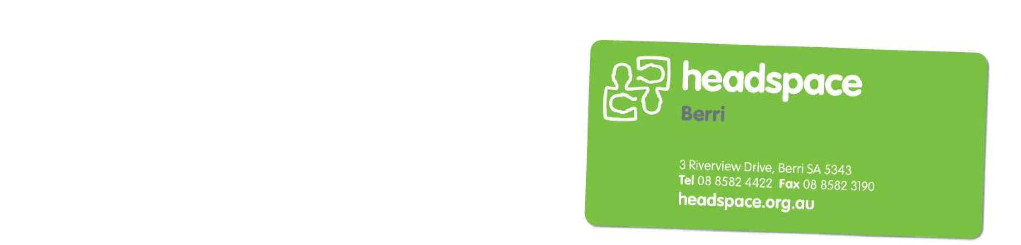
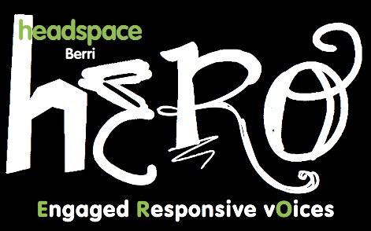
- What interested you about joining the headspace Berri hERO group?

- What interests do you have? (Eg. Social media, research, helping others, public speaking, health and wellbeing, event planning, arts, sports etc.)

- Are you involved with any community groups or organisations, and if so, which ones?

ABN 59 993 489 649 headspace National Youth Mental Health Foundation Ltd is funded by the Australian Government Department of Health and Ageing under the Youth Mental Health Initiative Program.

