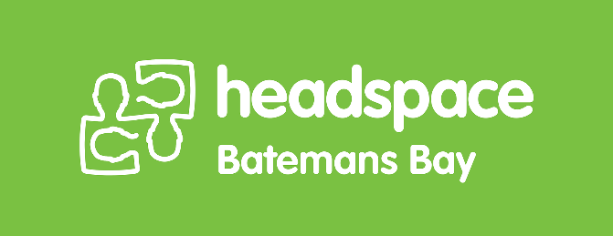
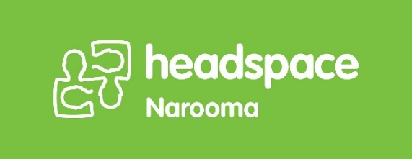
Position Description for Youth Reference Group (YRG)
headspace Batemans Bay & headspace Narooma
Role Summary
As a Youth Reference Group (YRG) member, you will provide your perspectives as a young person to support the service planning, design, delivery and continuous improvement of headspace Batemans Bay and headspace Narooma. YRG members contribute ideas, feedback and advice on programs, community engagement activities and youth mental health initiatives across the Eurobodalla.
Throughout your term, you will have opportunities to take part in participation activities that align with your interests, experiences and availability. This may include attending consultations, supporting events and workshops, contributing to youth-led projects, participating in campaigns, representing headspace at community forums, informing advocacy work, or providing input into resources and service improvements.
YRG members are supported through an orientation process, access to professional development (including Youth Mental Health First Aid), monthly meetings, regular check-ins with the Community Engagement & Awareness Worker, and a supportive group environment that values youth voice.

Position Context
Participation of young people is fundamental to the delivery of quality services at headspace and is a core element of the headspace model. headspace is committed to creating safe and meaningful opportunities for young people to have a genuine say in matters that affect them.
The YRG is a key mechanism for youth participation at headspace Batemans Bay and headspace Narooma. The group plays an active role in service planning, design, delivery and continuous improvement by ensuring youth voice remains central to decision-making.
The YRG is supported by the Community Engagement & Awareness Worker and works closely with the wider headspace Batemans Bay and headspace Narooma teams. Both centres are operated by Relationships Australia Canberra & Regions (RACR), and the YRG contributes youth perspectives that help strengthen service quality and community connection across the Eurobodalla.

Responsibilities
YRG members will be required to:
- Engage in and actively contribute to a range of participation activities to inform and collaborate on the work of headspace Batemans Bay and headspace Narooma.
- Safely share youth perspectives and experiences to help improve services, programs and the overall youth experience.
- Complete orientation, induction and ongoing professional development relevant to the role, including Youth Mental Health First Aid training (if available).
- Attend and actively contribute to monthly meetings including participation with manager, clinical lead and other staff as relevant at these meetings.
- Respond regularly to communications from the Community Engagement & Awareness Worker and fellow YRG members on agreed platforms.
- Complete written tasks when required, including wellbeing check-ins or feedback forms.
- Support headspace activities such as:
  - community events, school visits and workshops
  - youth mental health awareness campaigns
  - speaking opportunities or advocacy roles (optional)
- Represent headspace when participating in activities with staff and community partners.
- Work collaboratively, respectfully and inclusively with staff and peers from diverse backgrounds.
- Continually build knowledge and understanding of Aboriginal and Torres Strait Islander cultures and experiences.

Selection Criteria
Essential
- Aged 16–25 years at the time of application.
- Live, work or study in the Eurobodalla region.
- Passionate about improving youth mental health and wellbeing.
- Able to attend meetings, where possible, including consortium meetings, interview panels and participate in activities regularly.
- Able to work respectfully with diverse young people.
- Open to learning, sharing ideas and contributing in a team environment.
- Motivated and willing to commit for at least 12 months.
Valued but not required
- Lived experience with mental health or alcohol and other drug challenges (personal or through supporting someone).
- Experience with community engagement, creative arts, school leadership, advocacy, cultural knowledge or social action.
We encourage applications from:
- Aboriginal and/or Torres Strait Islander young people
- LGBTQIA+ young people
- Culturally and linguistically diverse young people
- Neurodiverse young people
- Young people with disability
- Young men
- Young people with caring roles

Checks and Requirements
Because this role involves working with children and young people, the following may be required:
- Working With Children Check (WWCC) – If you are over 18. Our local centre can support you in obtaining this.
- National Police Check – Our local centre can assist with this process.
- Volunteers under 18 require parent/guardian consent, a form will be sent to successful applicants for their parent/guardian to sign.

How to Apply
A link or QR code is shared on the headspace Batemans Bay and headspace Narooma website and social media.
Shortlisted applicants will be invited to an interview to meet the team, learn more about the role and discuss their interest in joining the YRG.

