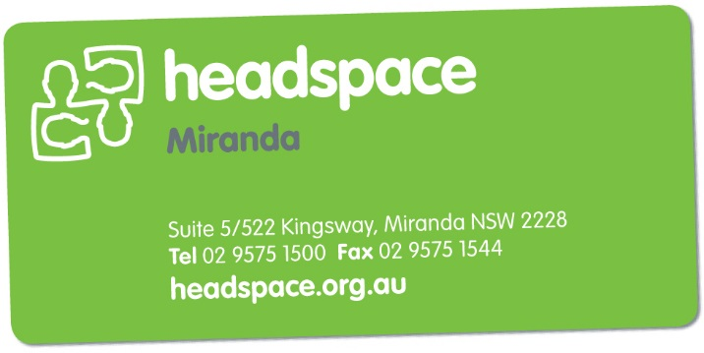
Get Work Ready
Group program
Expressions of Interest
Please type or write in the boxes below
Personal Information
Name:
Contact number:
Address:
Email
Age (& DOB):

Education and Work Information (please circle)
Currently working: | Yes/No
Looking for work: | Yes/No
Currently studying: | Yes/No
Level of study: | High school/Tafe/Private college/University

Other Information (please circle)
How did you find out about this group? | Website/friend/parent/carer/facebook/school/Tafe  Other (please specify):
I am happy to be contacted for further group programs similar to this? | Yes/No

Preferred days/times you are available to attend the group (please tick)
Mon: | AM. Avail  PM. Not Avail | AM. Avail  PM. Not Avail | Preferred Time:
Tues: | AM. Avail  PM. Not Avail | AM. Avail  PM. Not Avail | Preferred Time:
Weds: | AM. Avail  PM. Not Avail | AM. Avail  PM. Not Avail | Preferred Time:
Thurs: | AM. Avail  PM. Not Avail | AM. Avail  PM. Not Avail | Preferred Time:
Friday: | AM. Avail  PM. Not Avail | AM. Avail  PM. Not Avail | Preferred Time:

Once completed please email to headspace.miranda@cesphn.com.au

