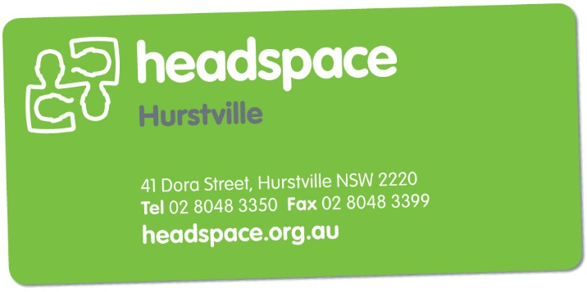headspace Hurstville  
Service Provider

Referral Form

[Select Date]

|  |  |  |  |  |  |  |  |  |  |
| --- | --- | --- | --- | --- | --- | --- | --- | --- | --- |
| Please fax referral to 02 8048 3399 or email to headspace.hurstville@cesphn.com.au  Please ensure all sections are completed, written referrals will only be accepted if writing is clear and legible. | | | | | | | | | |
| Our Intake Officers may be contacted during business hours on 02 8048 3350. | | | | | | | | | |
| Please note that we are NOT A CRISIS SERVICE. If crisis assistance is required, please call the NSW Mental Health Triage on 1800 011 511. Alternatively, direct your young person to an accident & emergency department of their nearest hospital. | | | | | | | | | |
| Has the Young Person (YP) consented to referral? | Yes |  | If “NO” referral cannot be accepted. | | | | | | |
| If the YP is under 16 years & living with parents/carers,  are they aware? | | | | Yes |  | No |  | N/A |  |

|  |  |  |  |  |  |  |  |  |  |  |  |  |  |  |  |  |  |  |  |  |  |  |  |  |  |  |  |  |  |  |  |  |
| --- | --- | --- | --- | --- | --- | --- | --- | --- | --- | --- | --- | --- | --- | --- | --- | --- | --- | --- | --- | --- | --- | --- | --- | --- | --- | --- | --- | --- | --- | --- | --- | --- |
| YOUNG PERSON’S DETAILS: | | | | | | | | | | | | | | | | | | | | | | | | | | | | | | | | |
| First Name: | | |  | | | | | | | | | | Surname: | | | | | | |  | | | | | | | | | | | | |
| Preferred Name: | | |  | | | | | | | | | | | | | | | | | | | | | | | | | | | | | |
| DOB: | | |  | | | | | | | | | | Age: | | | |  | | | Gender: | | | | | | | | |  | | | |
| Street Address: | | |  | | | | | | | | | | | | | | | | | | | | | | | | | | | | | |
| Suburb: | | |  | | | | | | | | | | | | | | | | | Post Code: | | | | | | | | |  | | | |
| Home Phone: | | |  | | | | | | | | | | | | | | | | | Can We Leave a Msg: | | | | | | | | |  | | | |
| Mobile: | | |  | | | | | | | | | | | | | | | | | Can We Leave a Msg: | | | | | | | | |  | | | |
| Email: | | |  | | | | | | | | | | | | | | | | | | | | | | | | | | | | | |
| Can we post letters to the above address? | | | | | | | | | | | | | | | | | | | | YES | | | |  | | NO | |  | UNKNOWN | | |  |
| [MANDATORY FIELD] NEXT OF KIN (NOK) DETAILS: must be a responsible adult >18yo. | | | | | | | | | | | | | | | | | | | | | | | | | | | | | | | | |
| Name: | | |  | | | | | | | | | | | | | | | | | | | | | | | | | | | | | |
| Relationship: | | |  | | | | | | | | | | | | | | | | | | | | | | | | | | | | | |
| Street Address: | | | As Above | | |  |  | | | | | | | | | | | | | | | | | | | | | | | | | |
| Suburb: | | |  | | | | | | | | | | | | | | | | | Post Code: | | | | | | |  | | | | | |
| Phone: | | |  | | | | | | | | | | Mobile: | | | | | | |  | | | | | | | | | | | | |
| Can we contact NOK? | | | | | | | | | | | | | | | | | | | | Yes | | | |  | | | Emergency Only | | | |  | |
| REFERRER’S DETAILS: | | | | | | | | | | | | | | | | | | | | | | | | | | | | | | | | |
| Name of referrer: | | | |  | | | | | | | | | | | | | | | | | | | | | | | | | | | | |
| Relationship to YP: | | | |  | | | | | | | | | | | | | | | | | | | | | | | | | | | | |
| Organisation Name: | | | |  | | | | | | | | | | | | | | | | | | | | | | | | | | | | |
| Street Address: | | | |  | | | | | | | | | | | | | | | | | | | | | | | | | | | | |
| Suburb: | | | |  | | | | | | | | | | | | | | | | | | Post Code: | | | | | |  | | | | |
| Phone: | | | |  | | | | Fax: | | | | | | | |  | | | | | | Mobile: | | | | | |  | | | | |
| Email: | | | |  | | | | | | | | | | | | | | | | | | | | | | | | | | | | |
| Would you like to attend the initial appointment? | | | | | | | | | | | | | | | | | | | | YES | | | |  | | NO | |  | UNKNOWN | | |  |
| YOUNG PERSON’S MEDICAL INFORMATION | | | | | | | | | | | | | | | | | | | | | | | | | | | | | | | | |
| Does the YP have their own GP? | | | | | | | | | | | | | | | | | | | | YES | | | |  | | NO | |  | UNKNOWN | | |  |
| Details (name, practice, address, phone): | | | | | | | | | | | |  | | | | | | | | | | | | | | | | | | | | |
| Has the YP ever received prior Mental Health care or has had other workers involved in their care? | | | | | | | | | | | | | | | | | | | | YES | | | |  | | NO | |  | UNKNOWN | | |  |
| Details (please list service & duration): | | | | | | | | | | | |  | | | | | | | | | | | | | | | | | | | | |
| Does the YP have a Mental Health Care Plan (MHTP)? PLEASE ATTACH A COPY if possible. Tick if Attached  | | | | | | | | | | | | | | | | | | | | YES | | | |  | | NO | |  | UNKNOWN | | |  |
| Date: | | | | |  | | | | | | | | | | | | | | | | | | | | | | | | | | | |
| Medicare Card? | | | | | YES | |  | | | NO | | | |  | | | | | Number/Other? | | | | | | |  | | | | | | |
| YOUNG PERSON’S CULTURE: | | | | | | | | | | | | | | | | | | | | | | | | | | | | | | | | |
| Aboriginal |  | Torres Strait Islander | | | | | |  | | | Both | | | |  | | | Neither | | | | |  | | Not Stated | | | |  | Refugee | |  |
| Family of origin/nationality: | | | | |  | | | | | | | | | | | | | | | | | | | | | | | | | | | |
| Country of Birth? | | | | |  | | | | | | | | | | | | | | | Arrival to Australia? | | | | | | | | |  | | | |
| Language spoken at home? | | | | |  | | | | | | | | | | | | | | | | | | | | | | | | | | | |
| Risk of homelessness? | | | | | YES | | | |  | | | | | | | NO | | | | |  | | | | | | | | | | | |

|  |
| --- |
| REFERRAL DETAILS: |
| What is the CURRENT concern regarding this young person? |
|  |
| What does the YOUNG PERSON see as the current concern? |
|  |
| Duration of the current problem: |
|  |
| [MANDATORY FIELD] Current Risk Taking (suicide, self-harm, homicide, risk taking behaviours, drug & alcohol as well as any relevant history or past attempts): |
|  |
| Further details relevant to presenting problem. Please include: lives with, mood, appetite, sleep, home environment, education/employment, relationships. |
|  |
| What assistance would you like from headspace Hurstville? Please be SPECIFIC. |
|  |

|  |
| --- |
| The referrer agrees that all information submitted in this referral is an accurate reflection of the client’s support needs, is correct with no information withheld for the organization to fulfil its duty of care to clients, staff and other partner agencies. |
| Referrer signature: _______________________________________ Date: ___________________________ |
| NB: headspace aim to contact you regarding this referral within 3 working days.  If you have not heard from us, PLEASE call us ASAP. |